**Application Deployment**

(Deploy the given React application to a production ready state)

**Application:**

Clone the below mentioned repository and deploy the application (Run application in port 3000).

Repo URL : <https://github.com/Vennilavan12/Trend.git>

**Docker:**

* Dockerize the application by creating Dockerfile
* Build an application and check output using docker image.

**Terraform:**

* Define infrastructure in main.tf to create VPC, IAM, EC2 with Jenkins, etc.
* Use terraform command to provision infrastructure.

**DockerHub:**

* Create a DockerHub repository.

**Kubernetes:**

* Setup Kubernetes in AWS EKS and Confirm EKS cluster is running.
* Write deployment and service YAML files.
* Deploy using kubectl via Jenkins.

**Version Control:**

* Push the codebase to a Git provider (GitHub).
* Add gitignore and dockerignore files and use CLI commands to push code.

**Jenkins:**

* Install Jenkins and necessary plugins (Docker, Git, Kubernetes, Pipeline) for build, push &deploy applications.
* Setup Github and jenkins integration using github webhook build trigger for auto build for every commit.
* Create a declarative pipeline script and pipeline project to build, push & deploy using CI-CD.

**Monitoring:**

* Setup a monitoring system to check the health of the cluster or application (opensource) is highly appreciable.

**Submission Guidelines:**

* GitHub Link: Submit full code repository.
* README File: Include setup instructions, pipeline explanation, and screenshots or create a document and attach all screenshots.
* Application deployed kubernetes Loadbalancer ARN.

**Output Screenshots:**

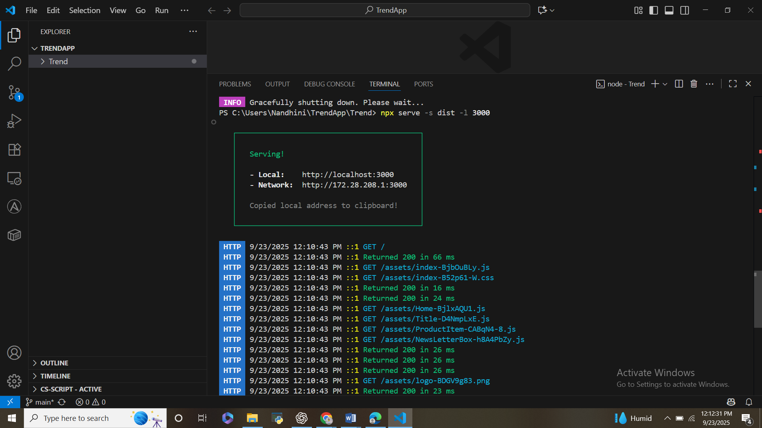

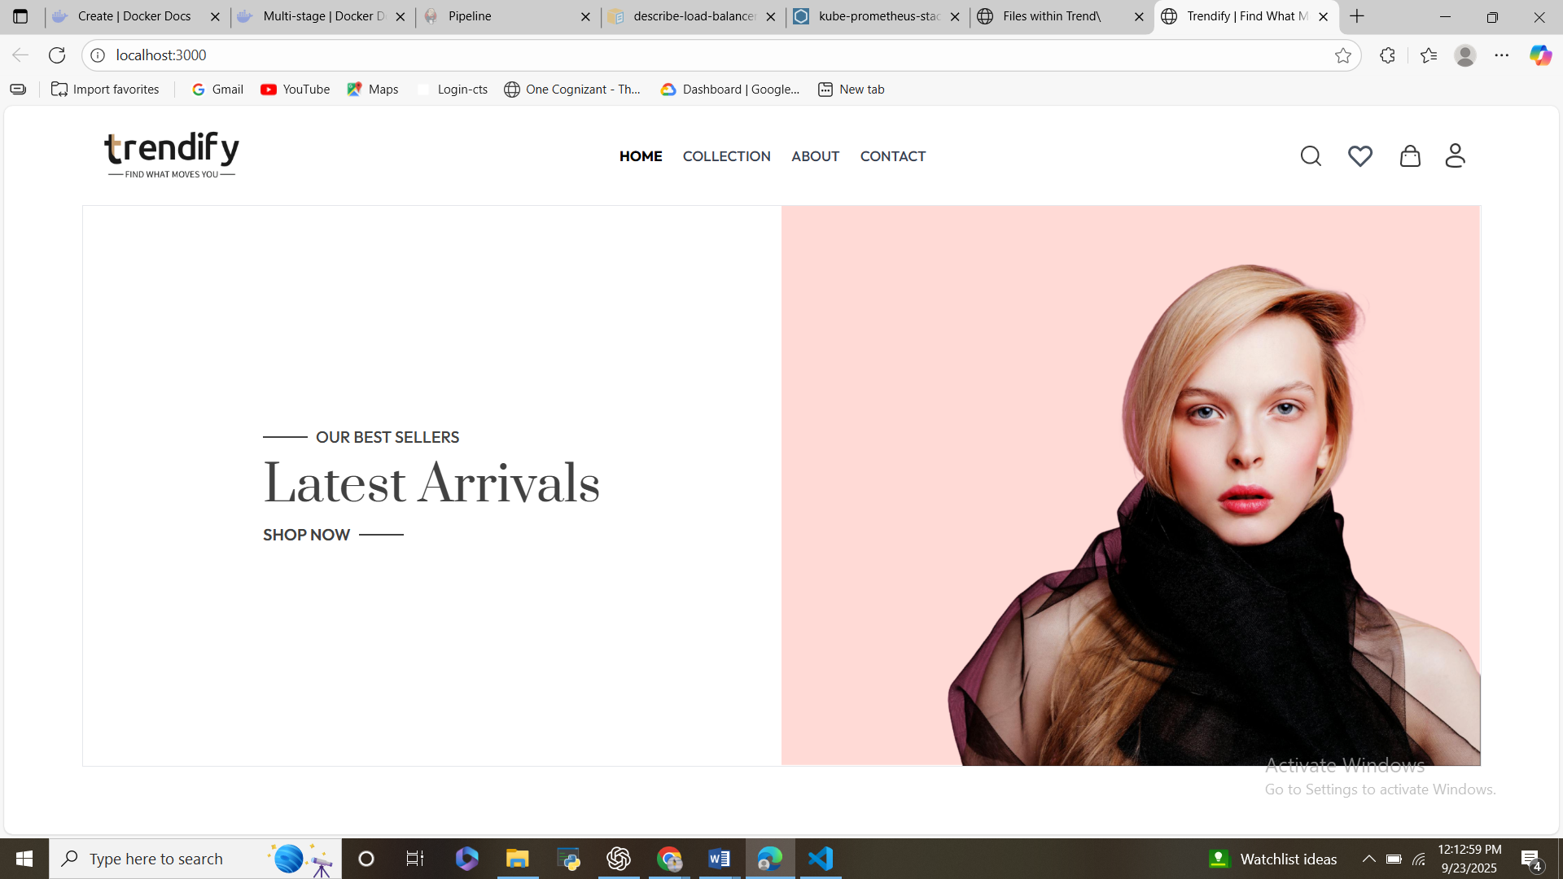

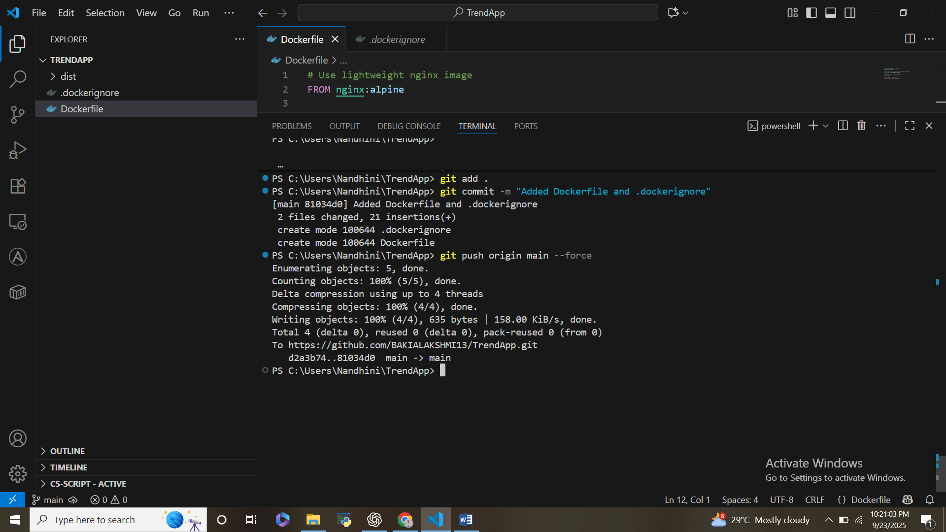

Build the Docker image

**1. Dockerization**

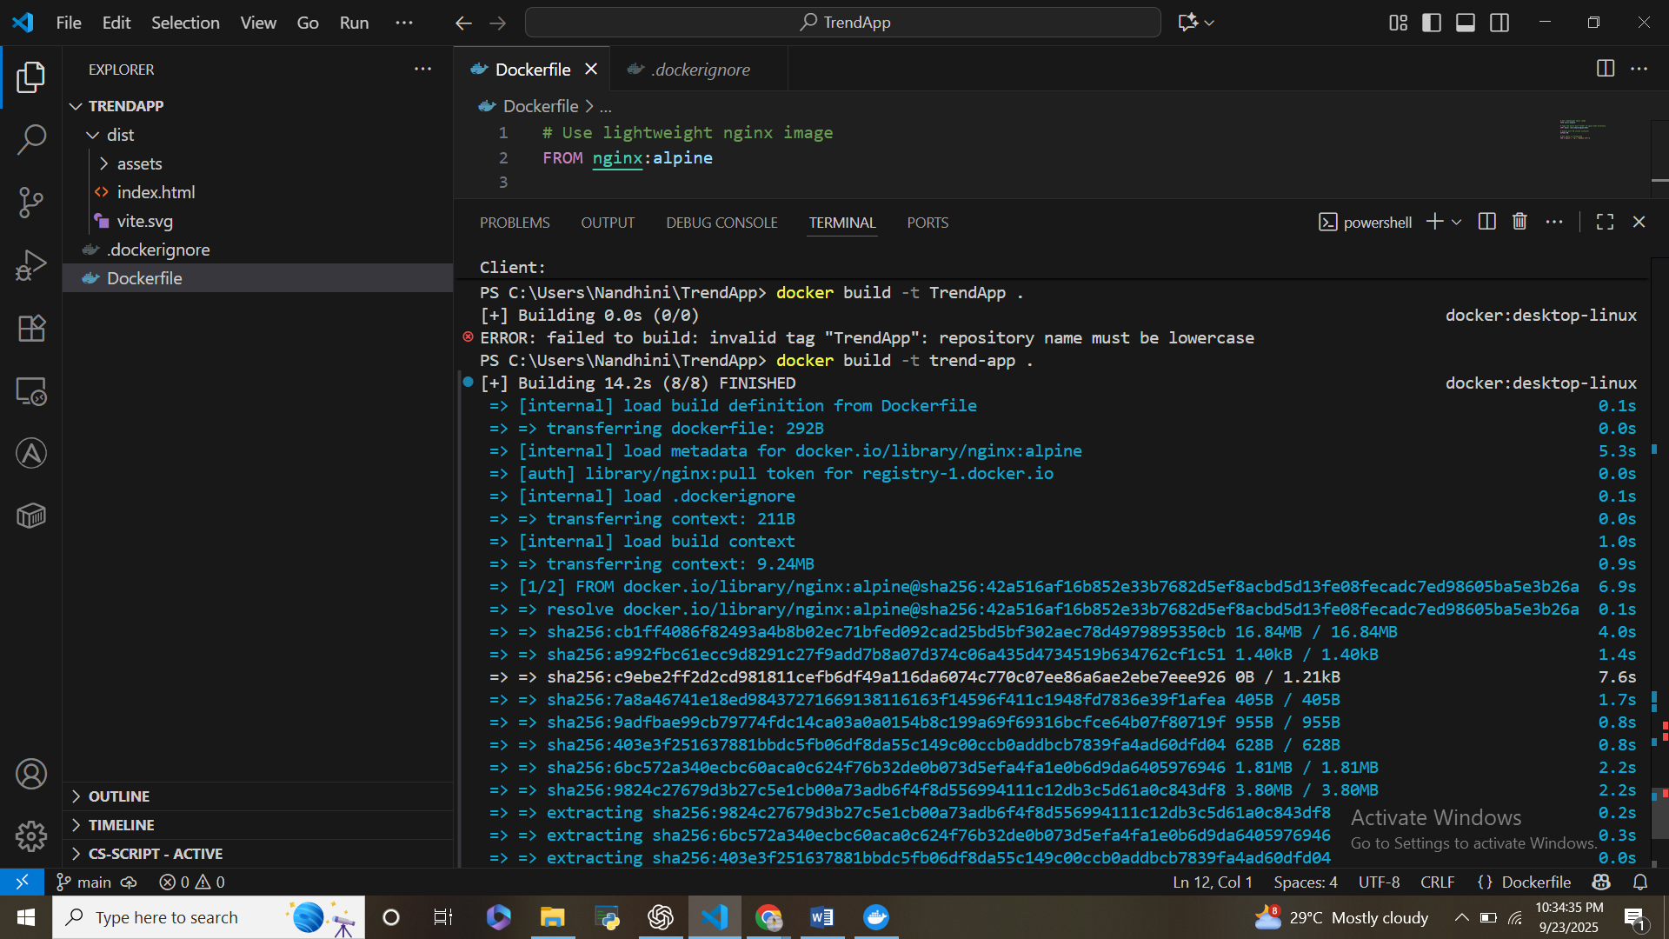

**Run the container**

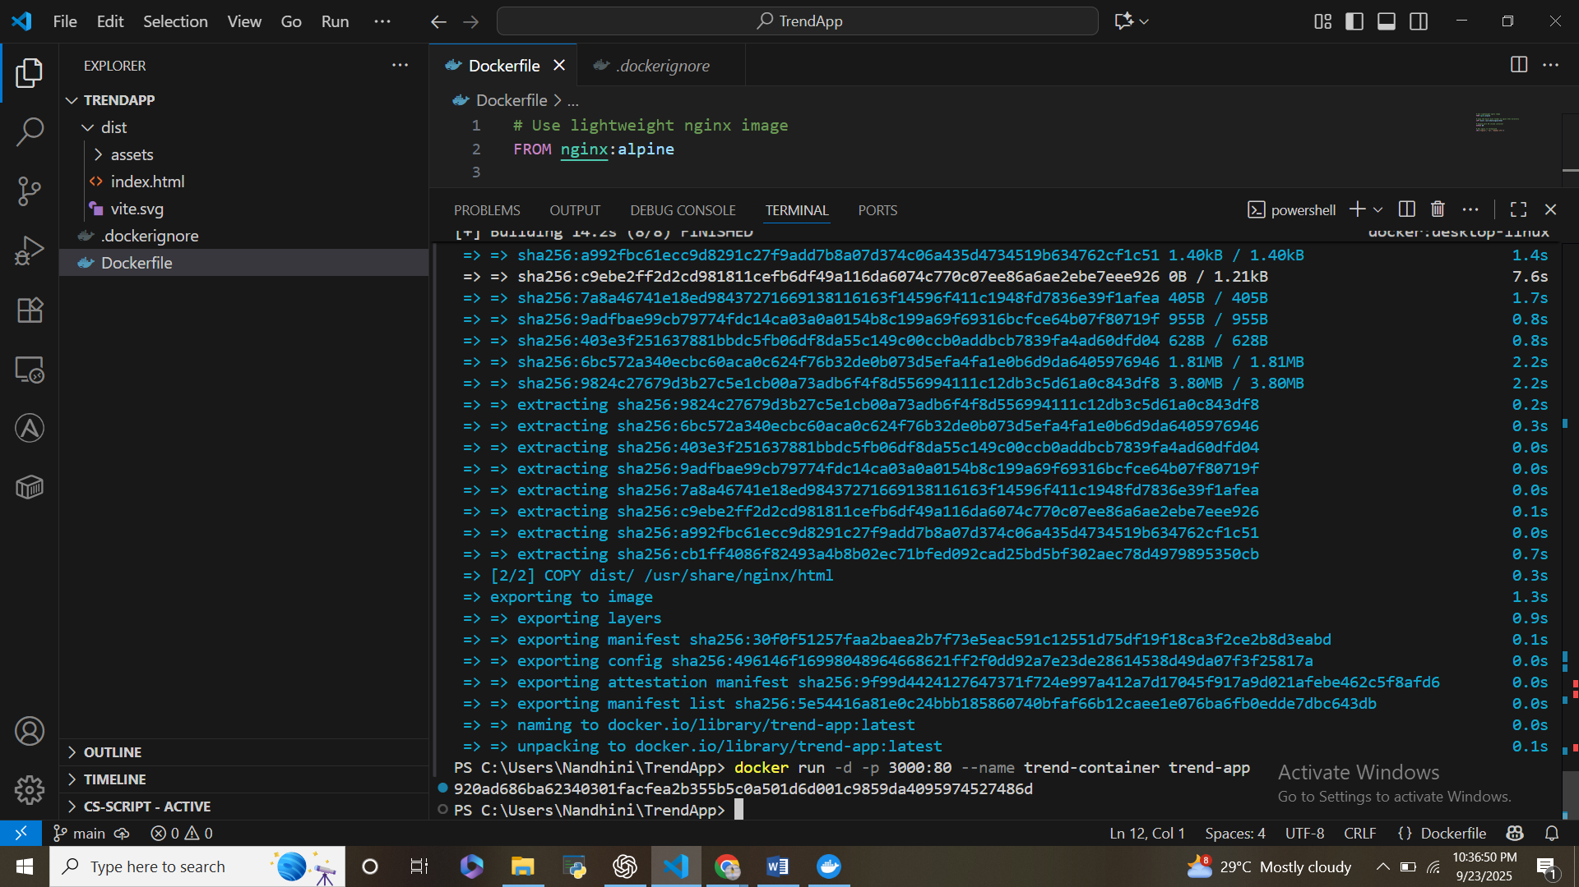

Open <http://localhost:3000>

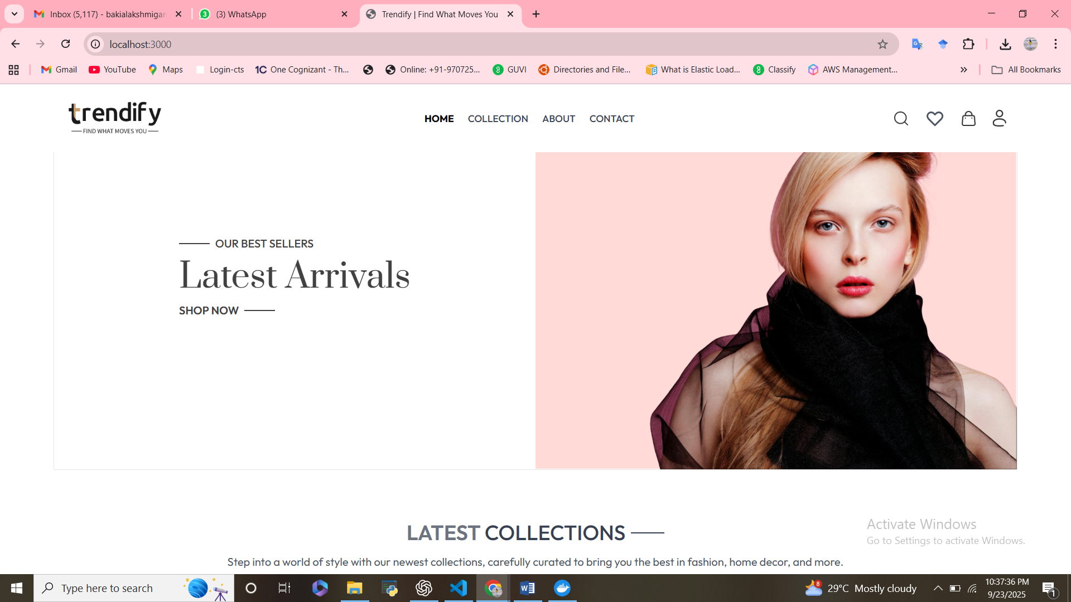

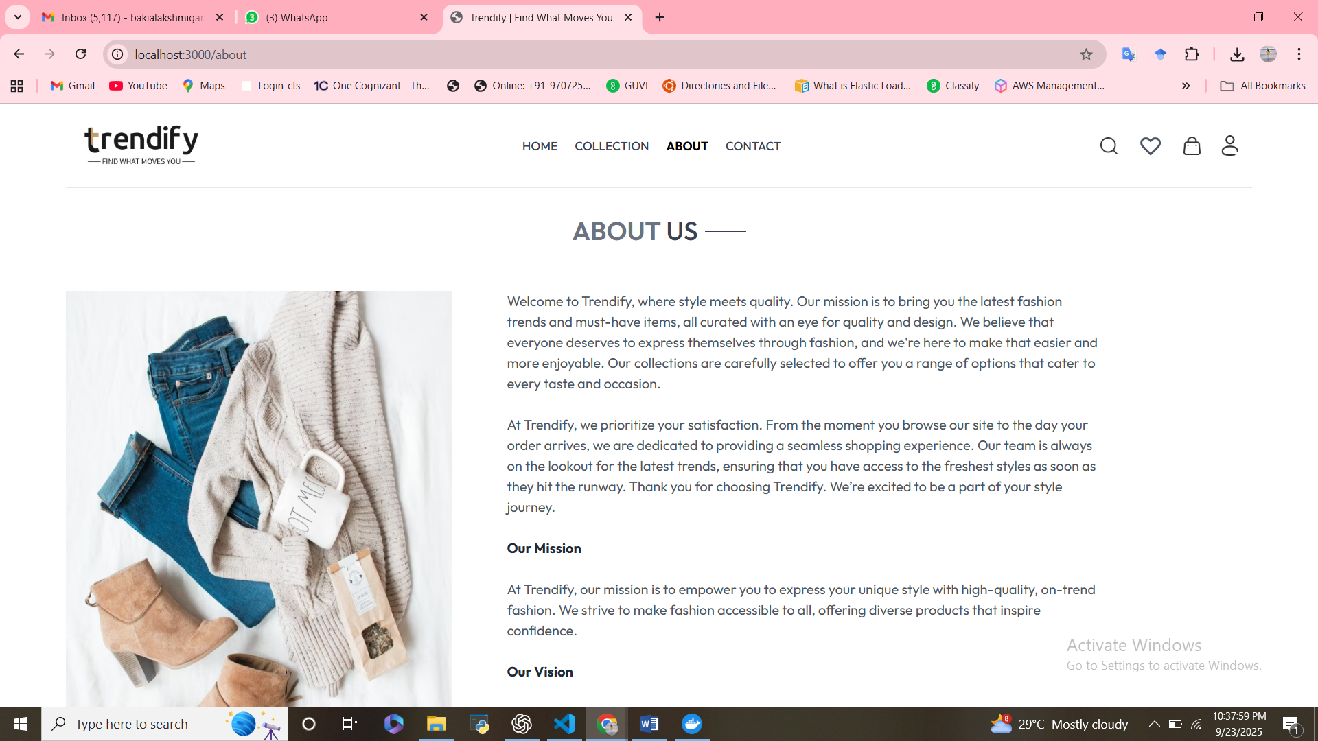

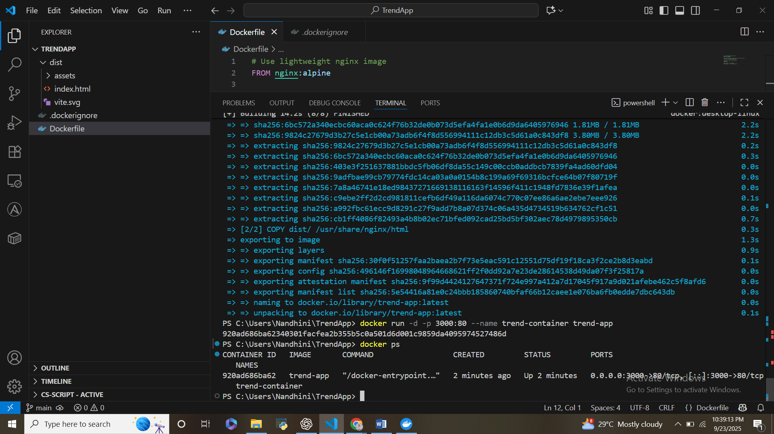

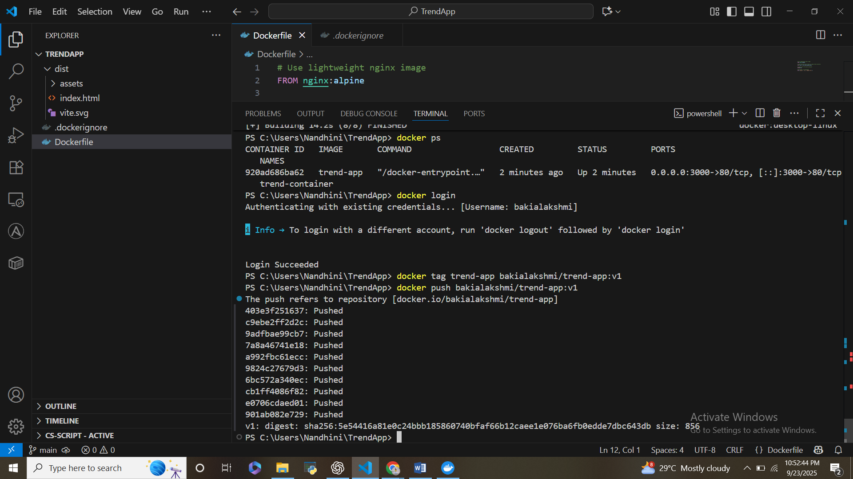

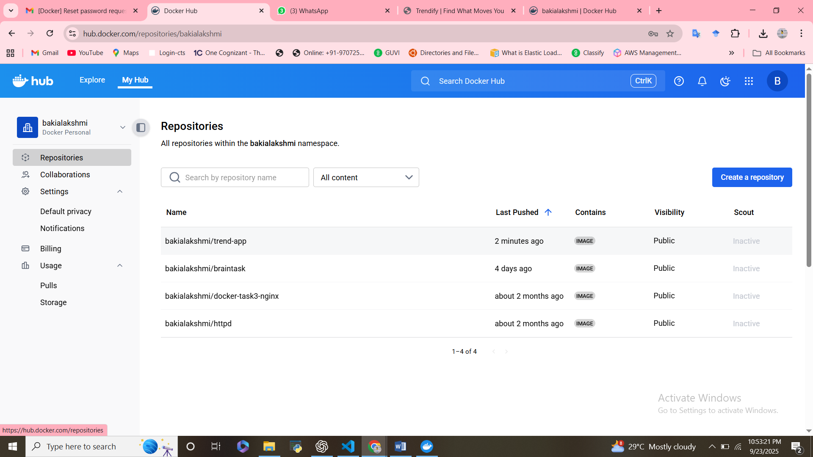

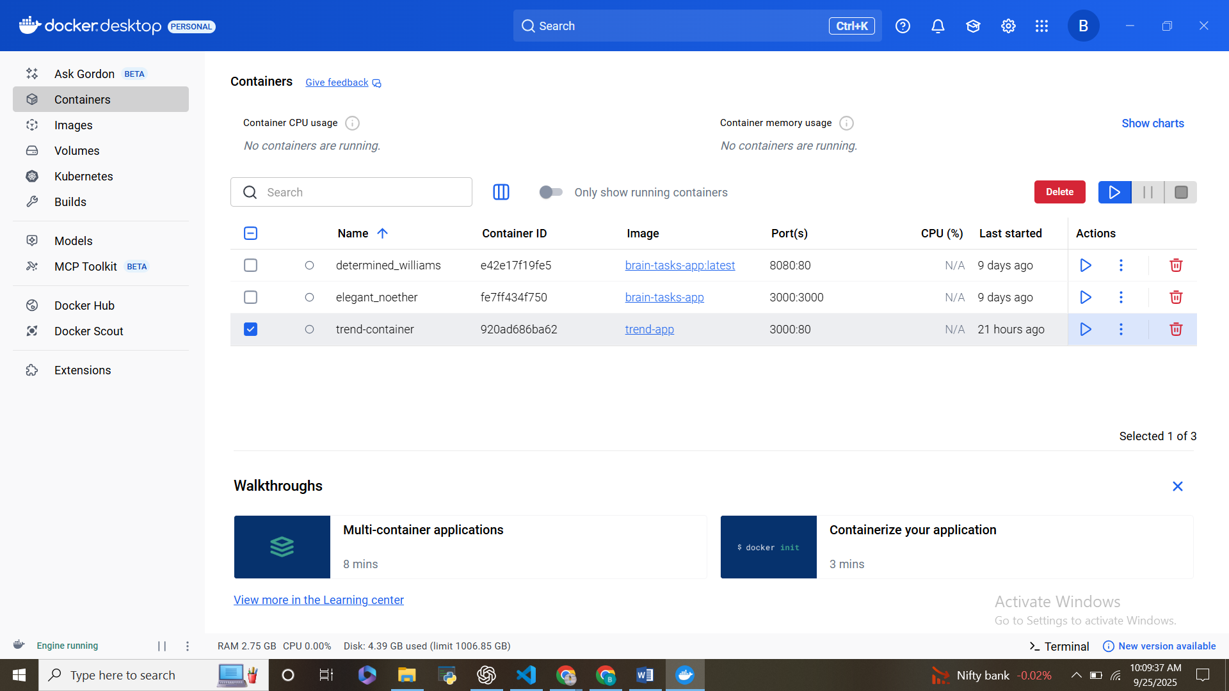

**2. Infrastructure with Terraform**

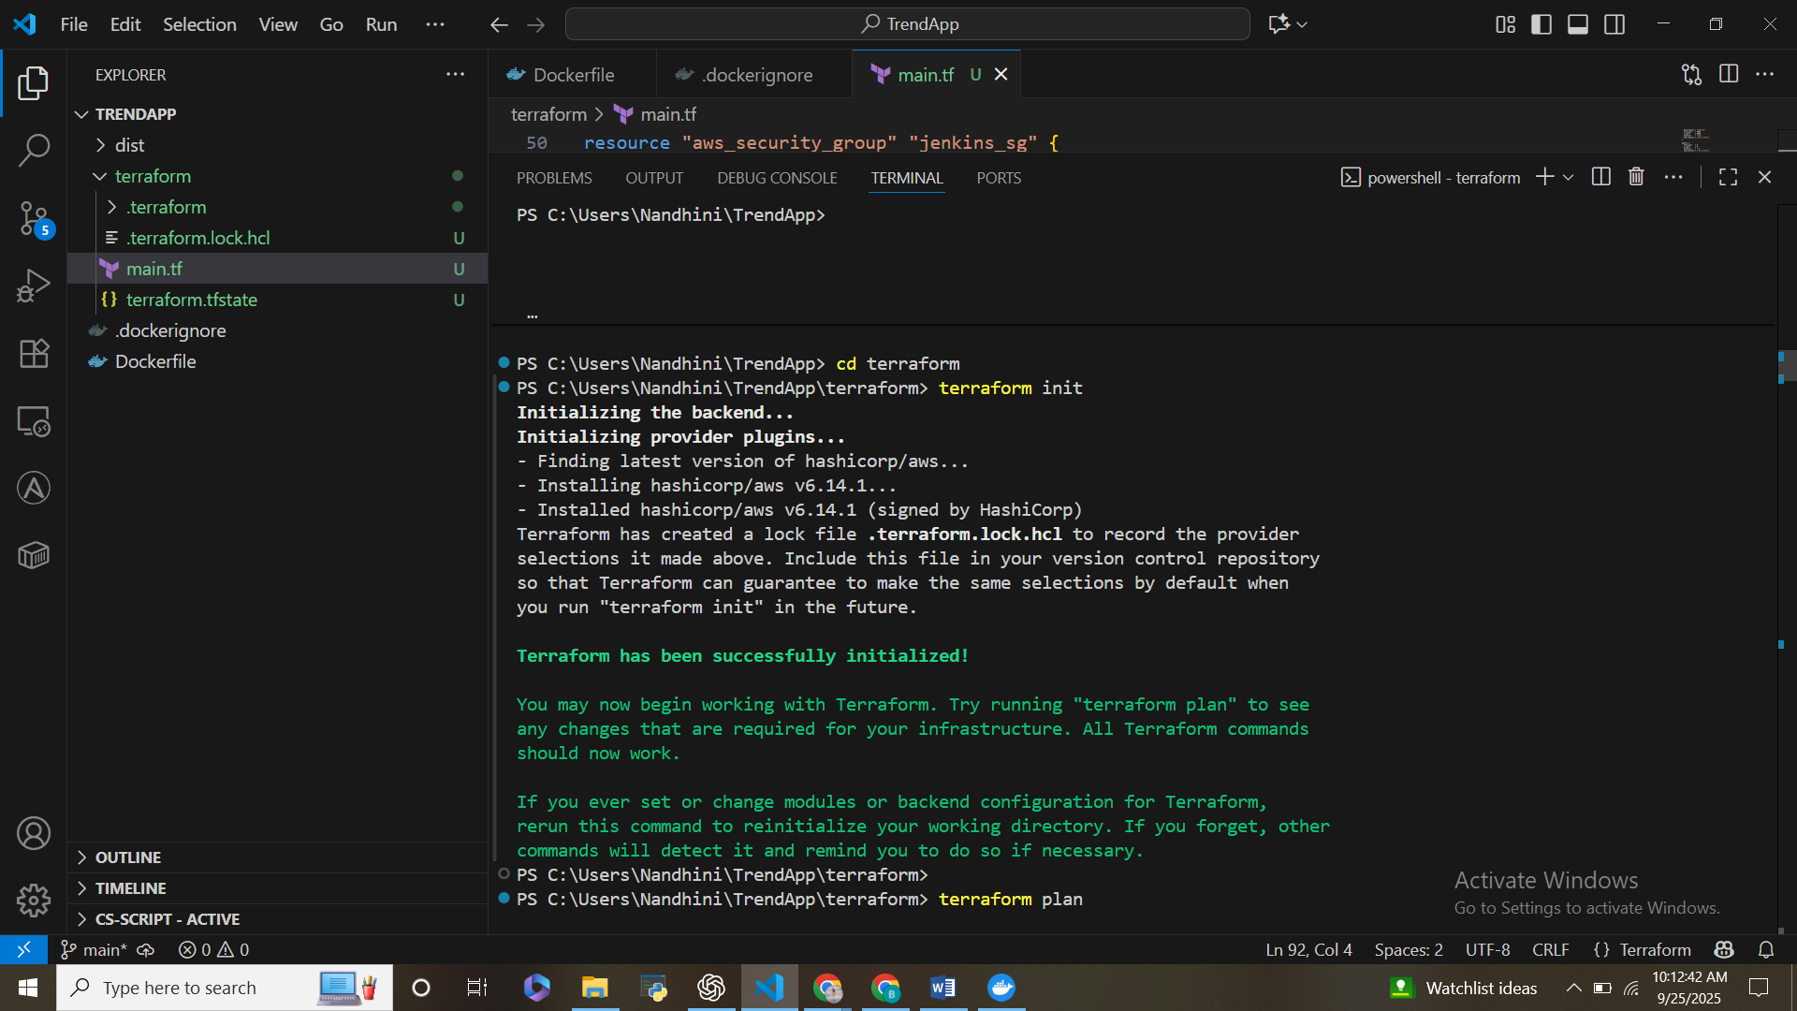

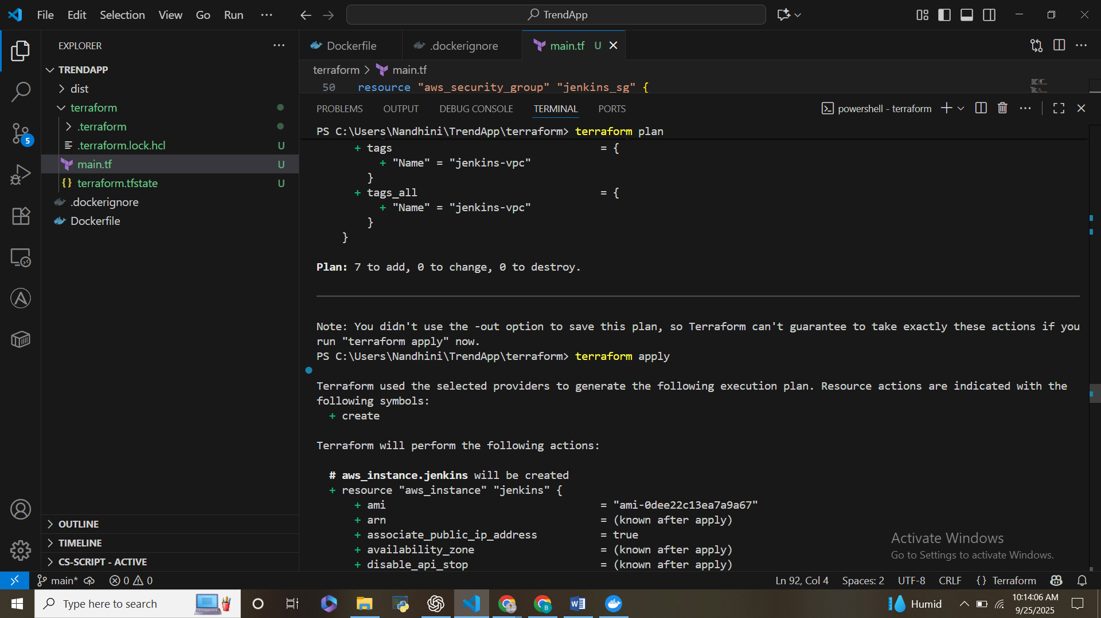

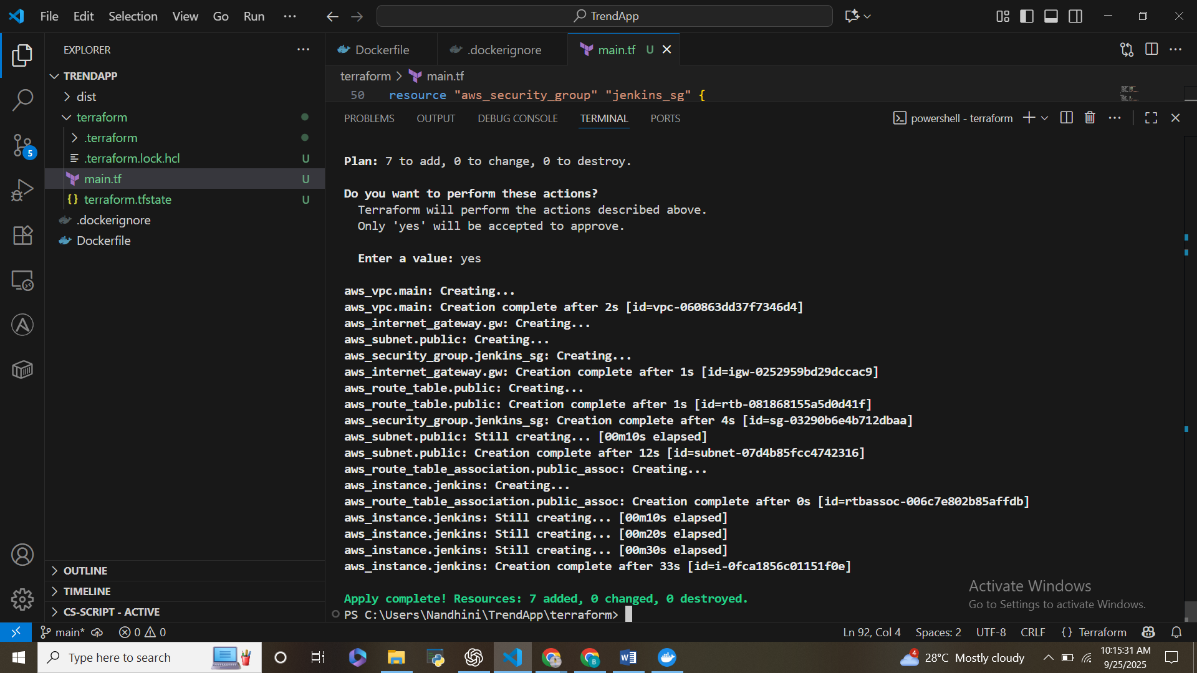

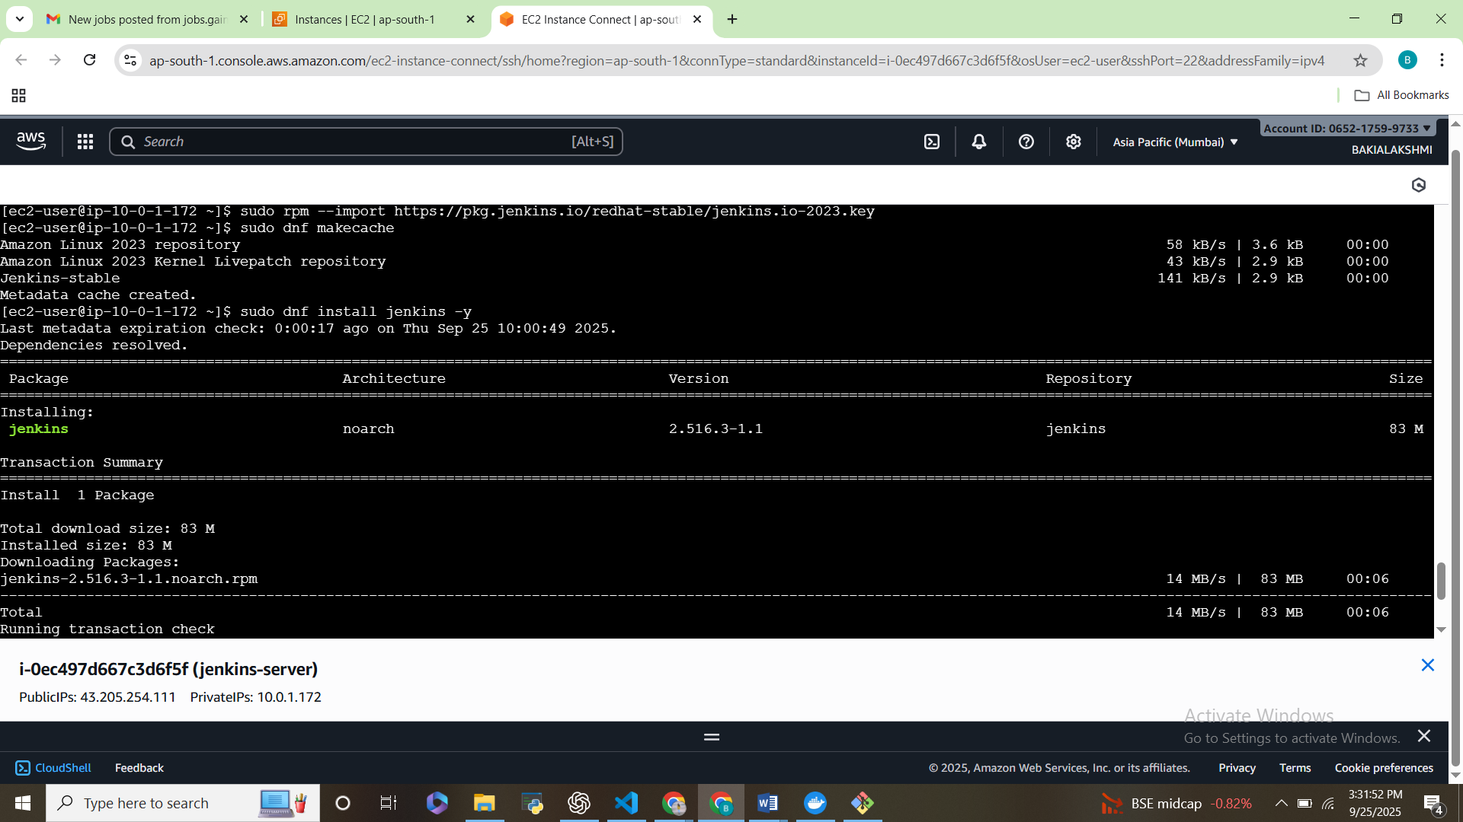

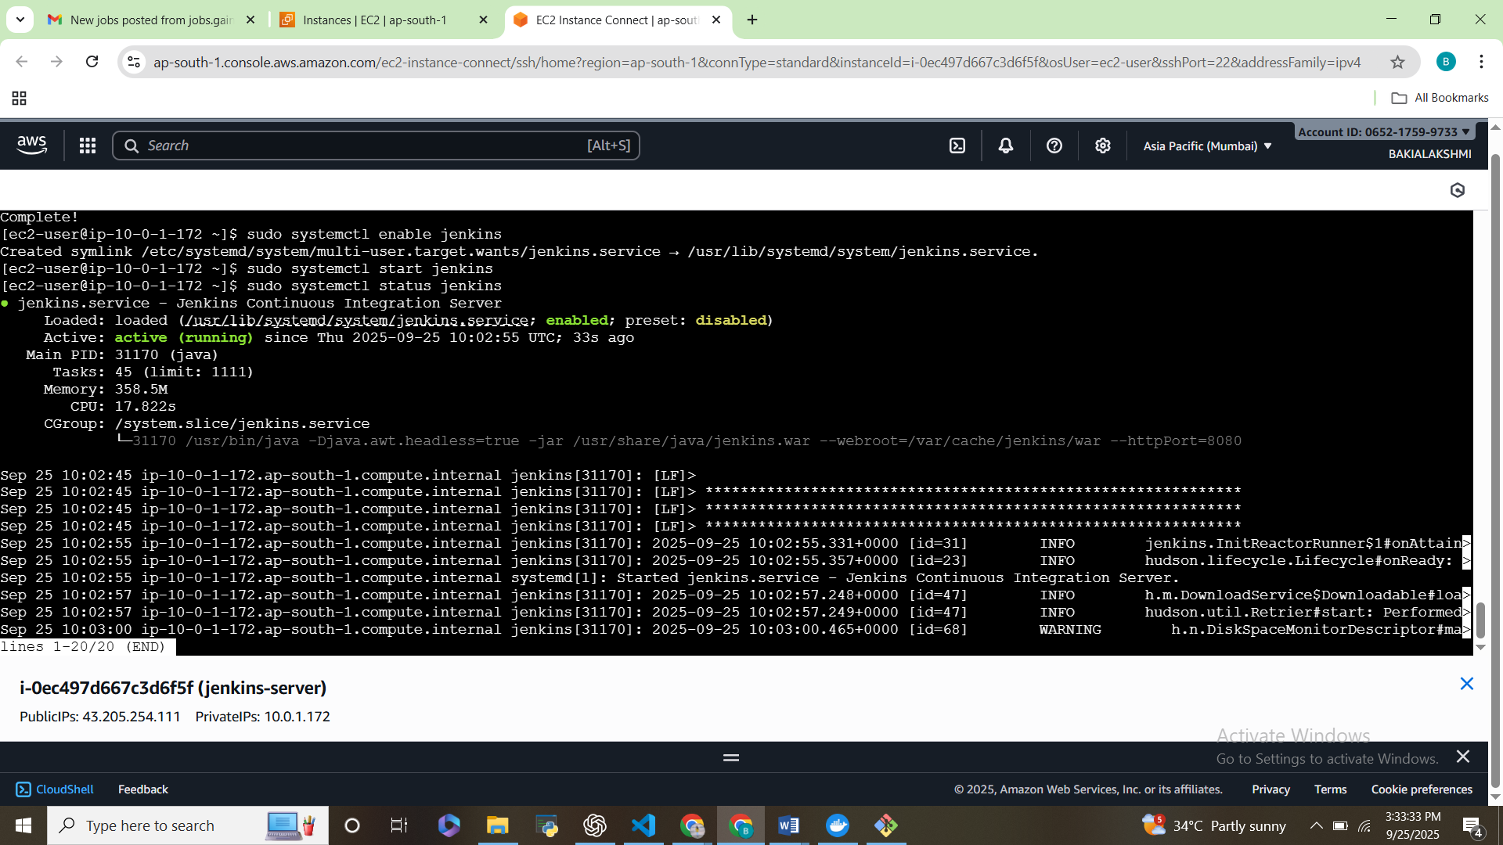

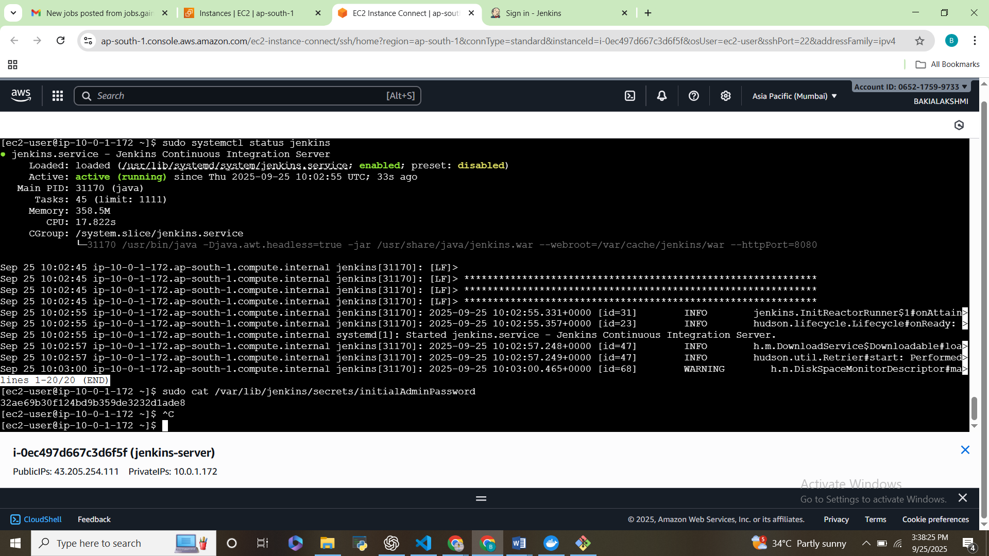

**3. CI/CD with Jenkins**

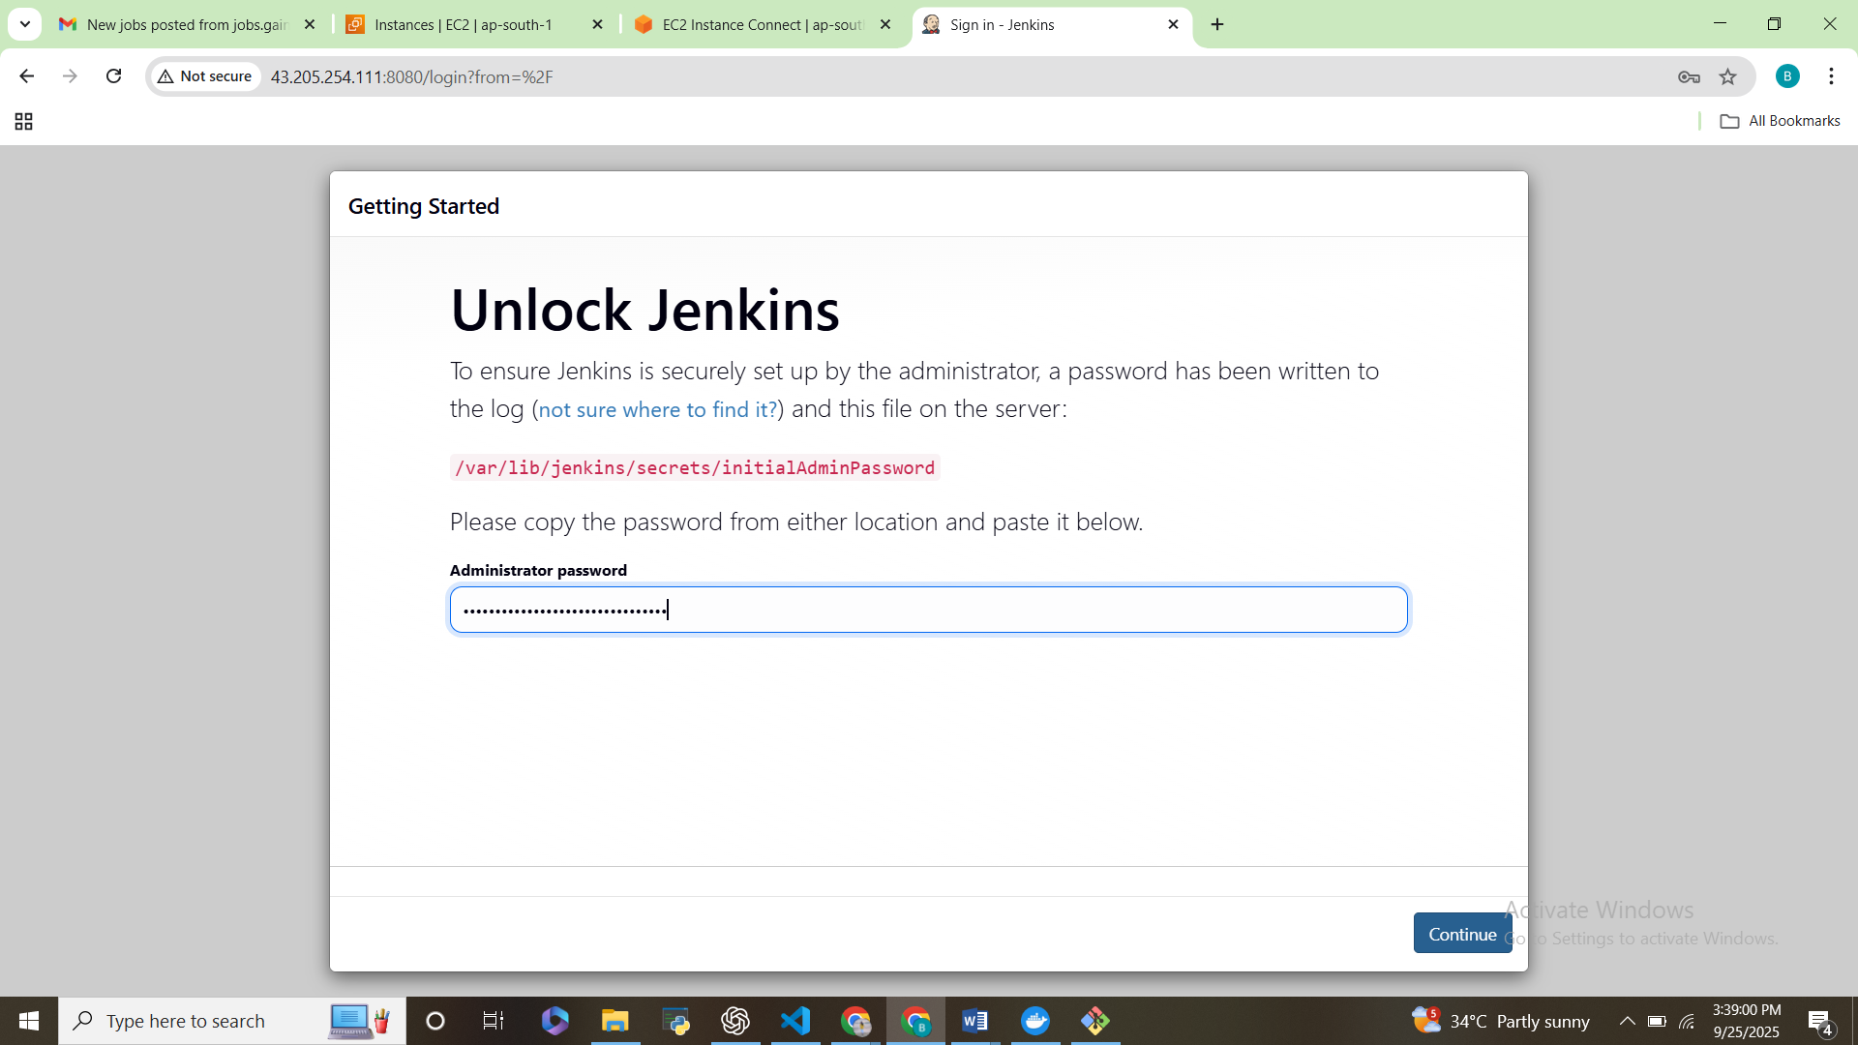

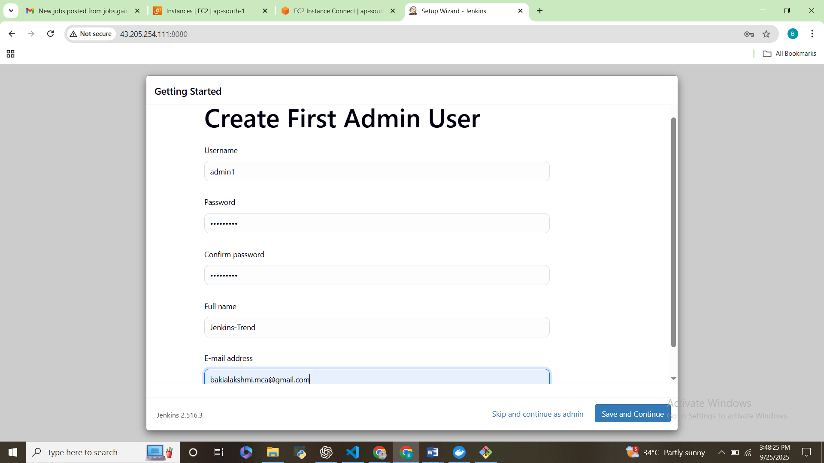

**Connect Jenkins to GitHub**

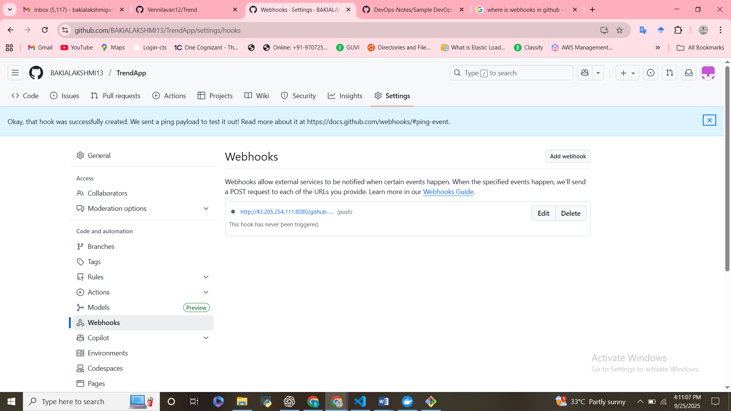

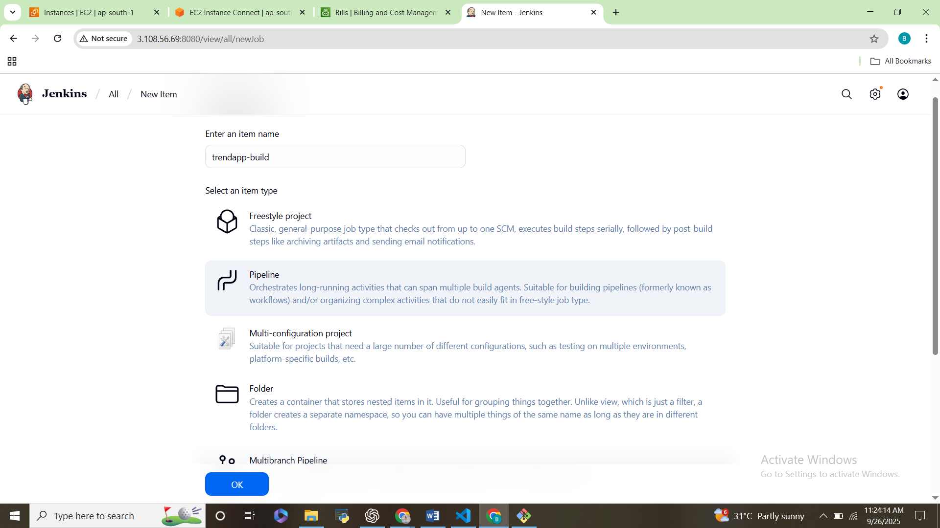

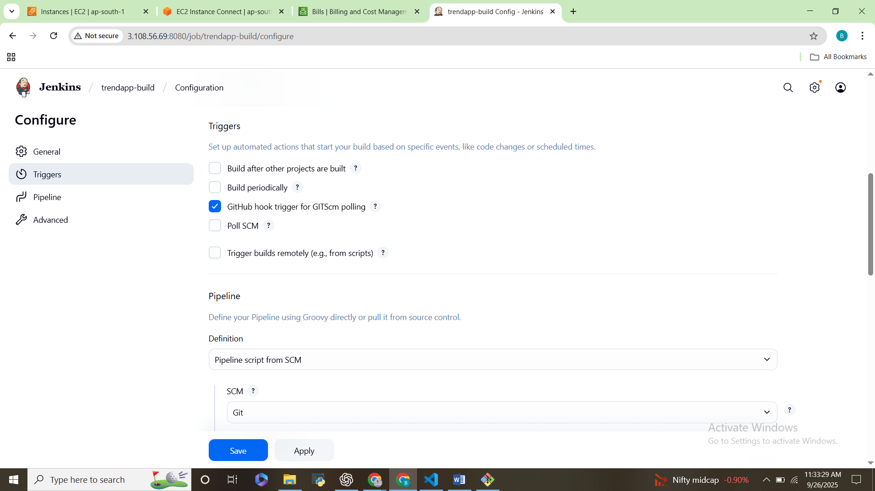

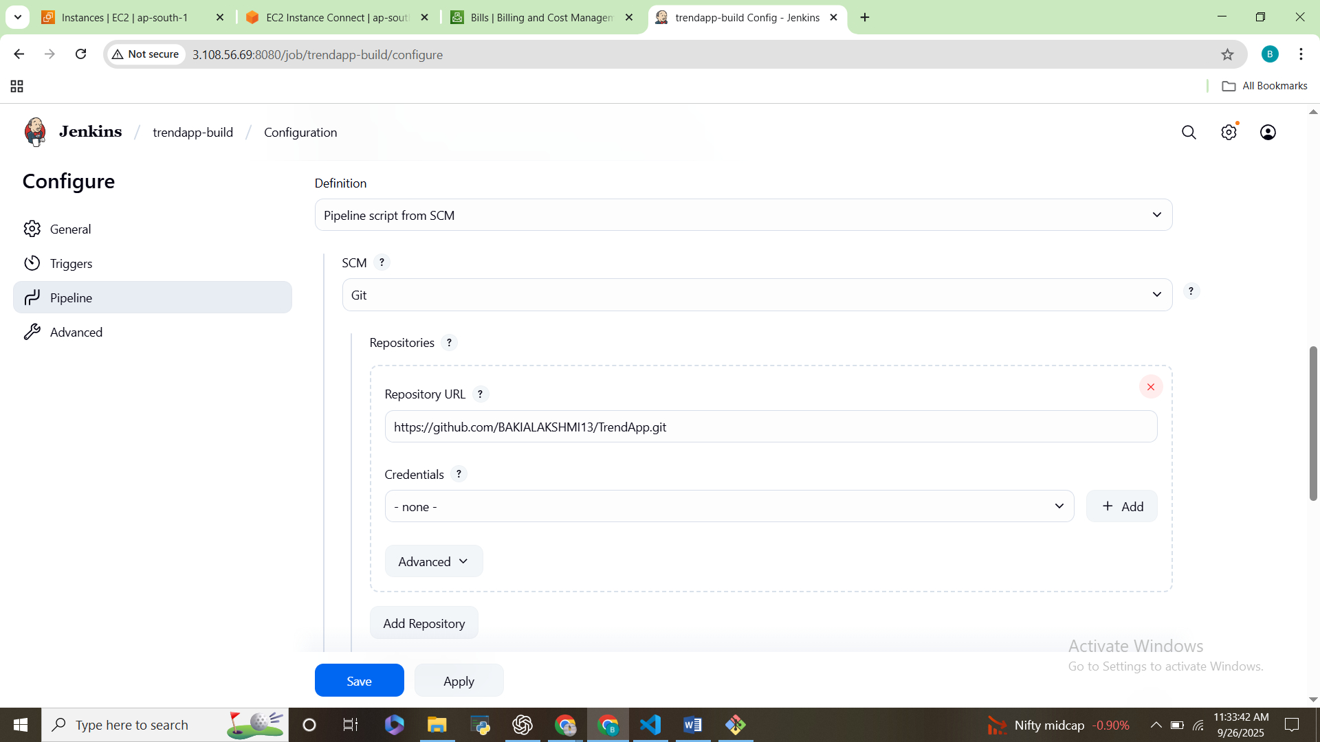

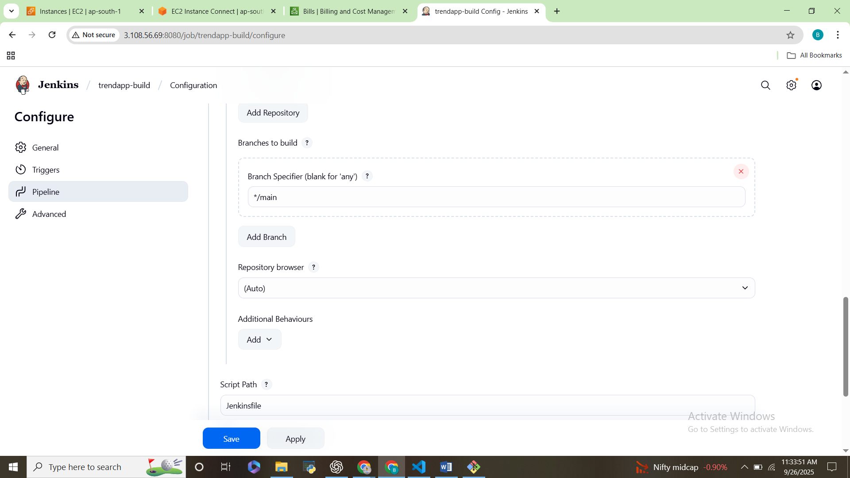

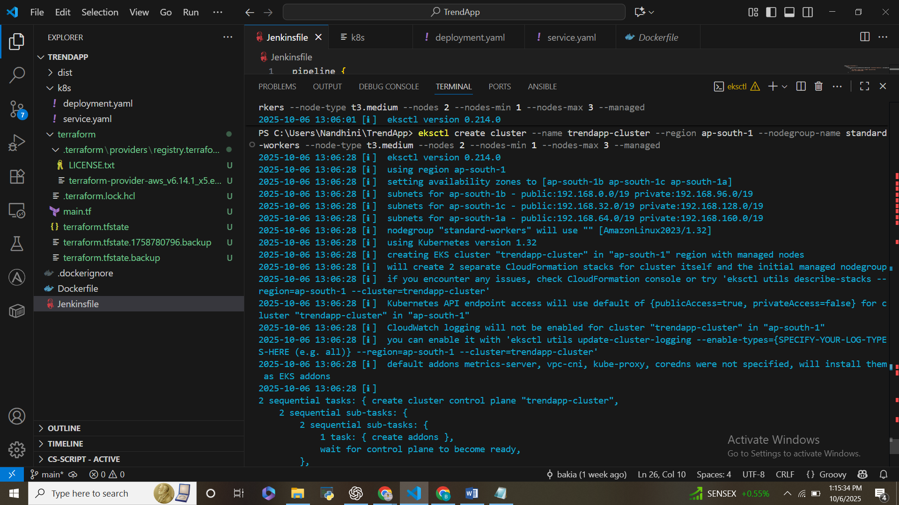

**4. Kubernetes Deployment**

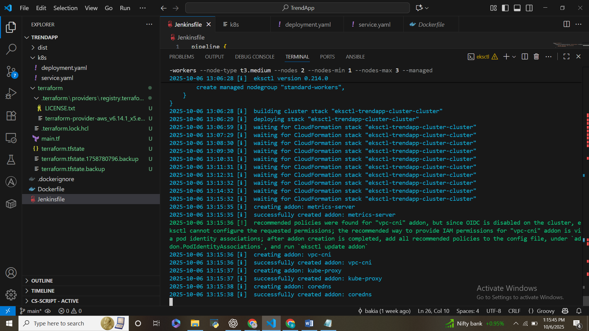

**Kubernetes Deployment**

**Applied `deployment.yaml` and `service.yaml` for TrendApp.**

**- Verified pods and services:**

**kubectl get pods**

**kubectl get svc**

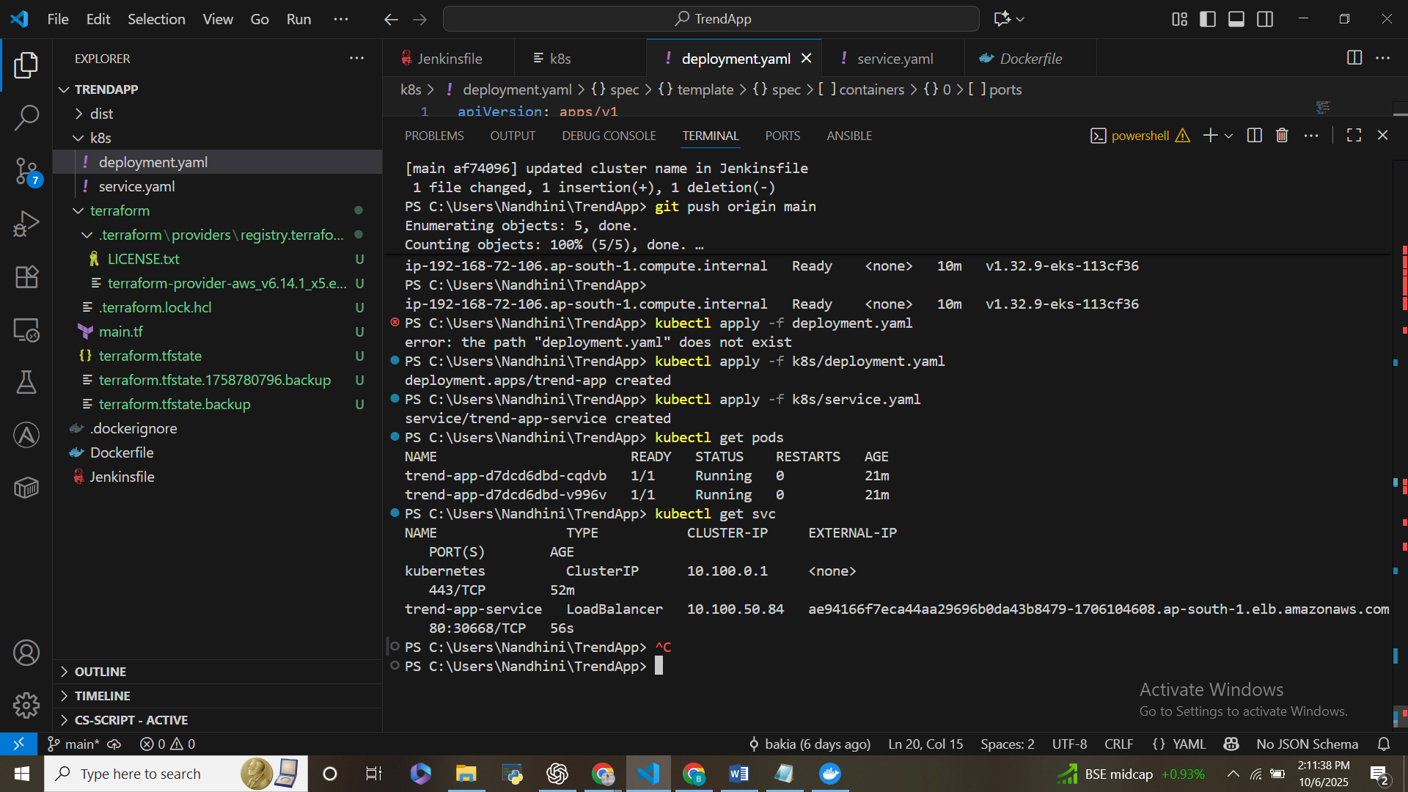

* TrendApp accessible via LoadBalancer **External IP**.

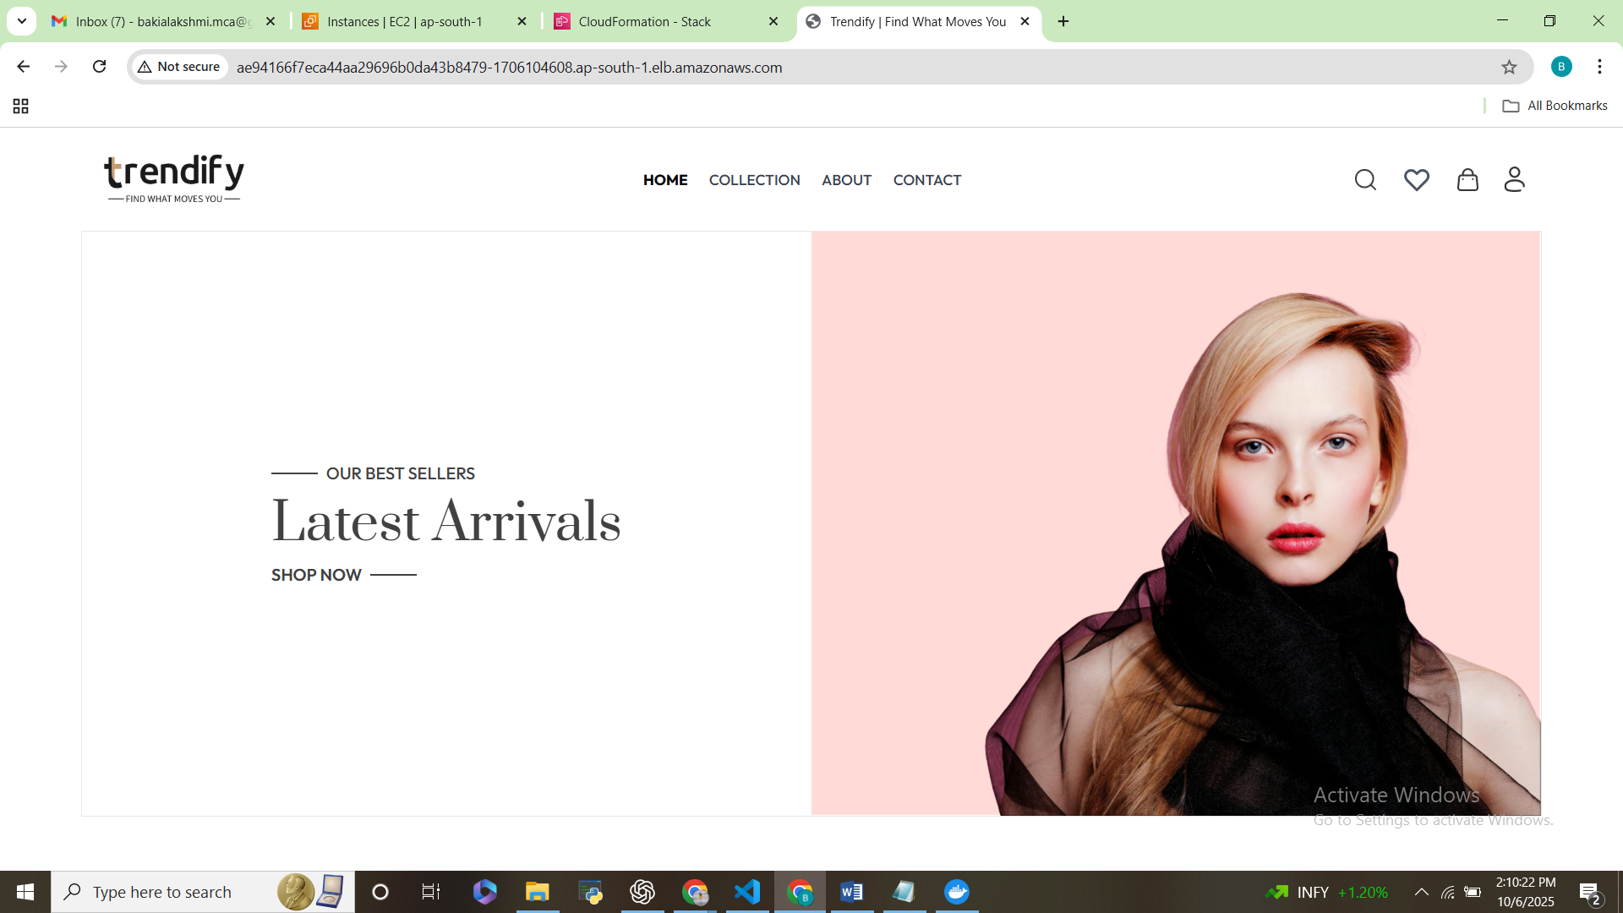

**Loadbalancer URL**- ae94166f7eca44aa29696b0da43b8479-1706104608.ap-south-1.elb.amazonaws.com

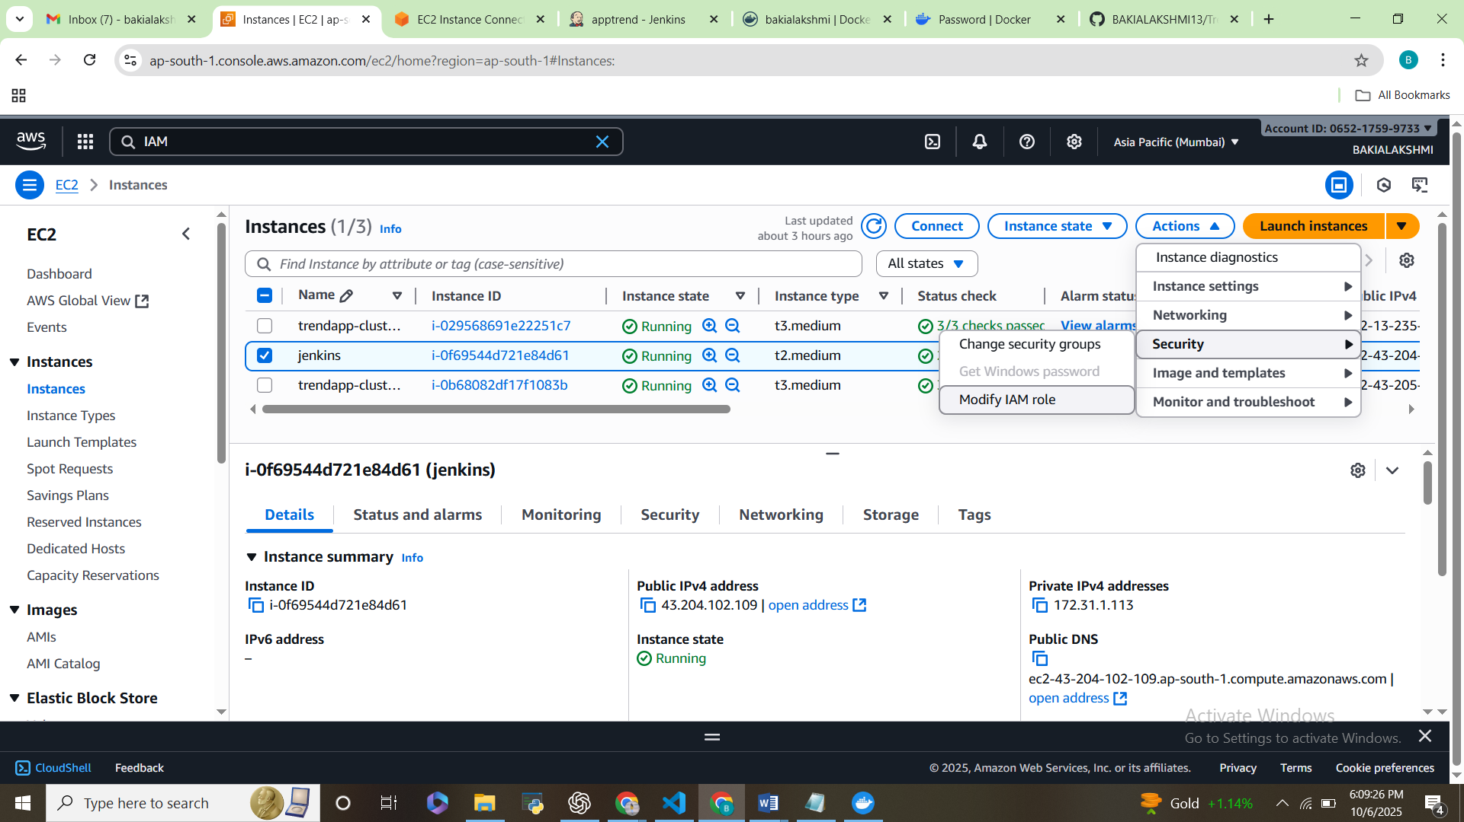

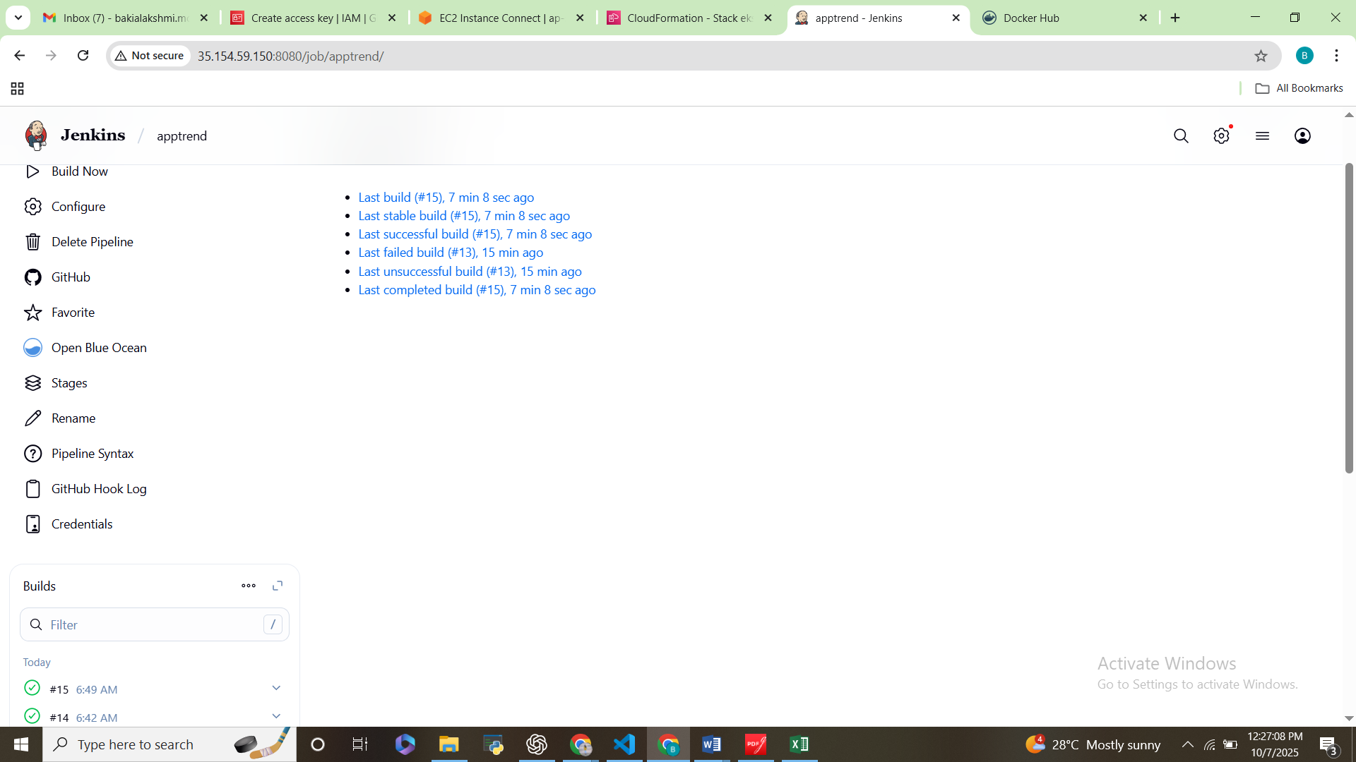

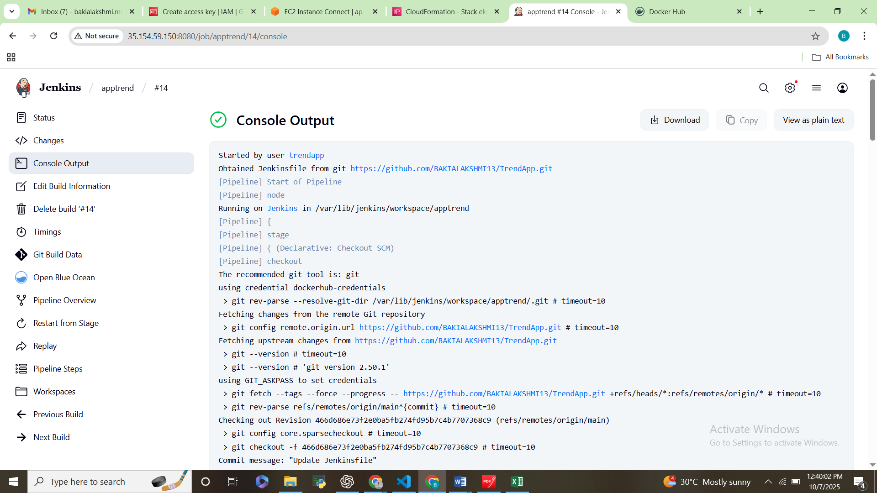

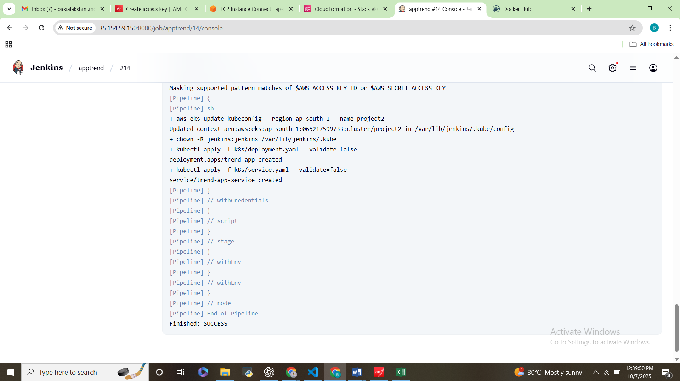

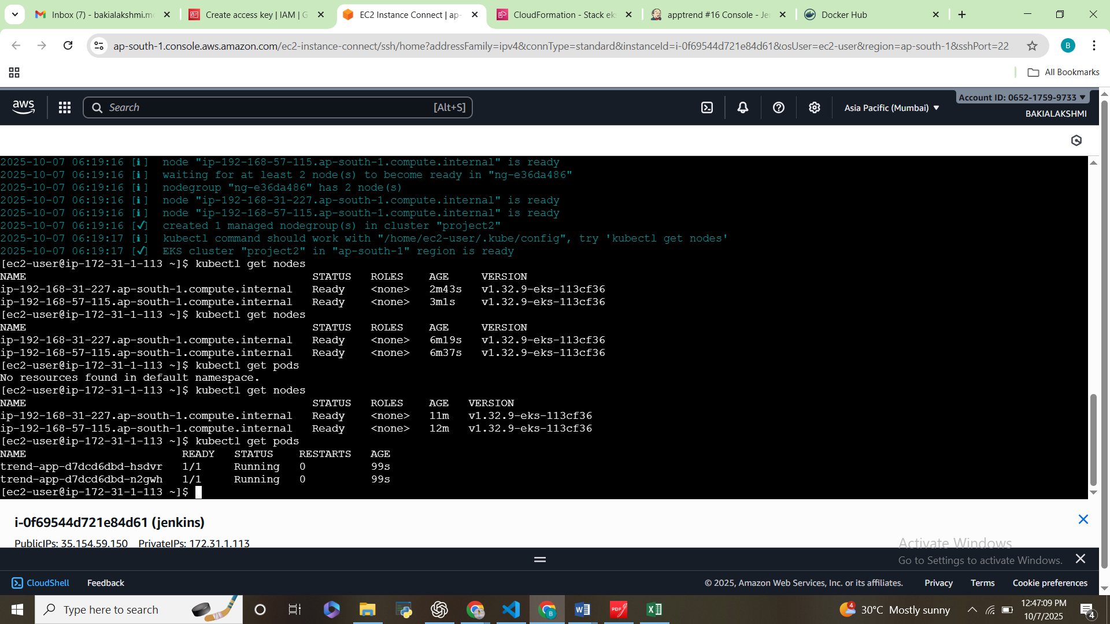

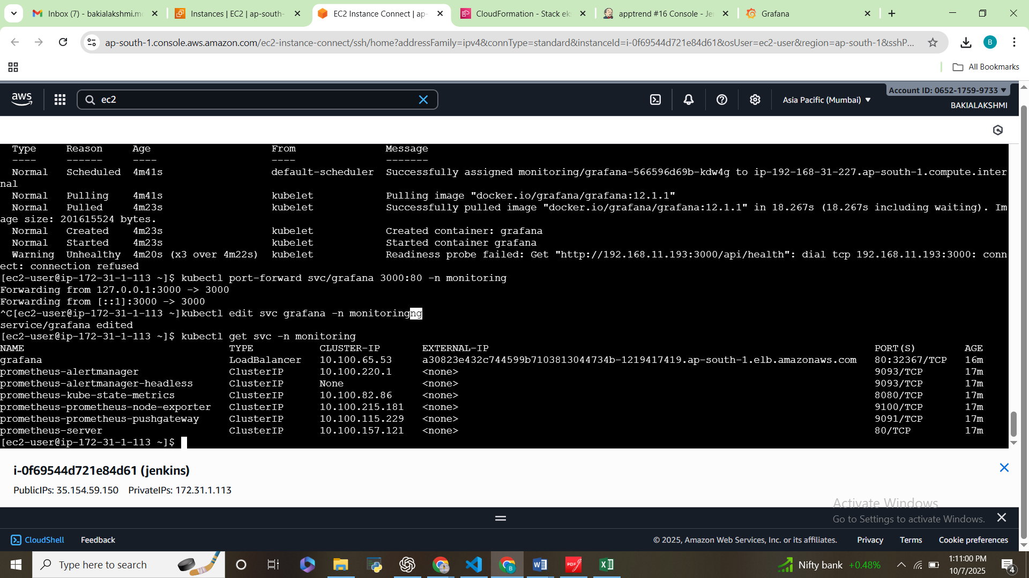

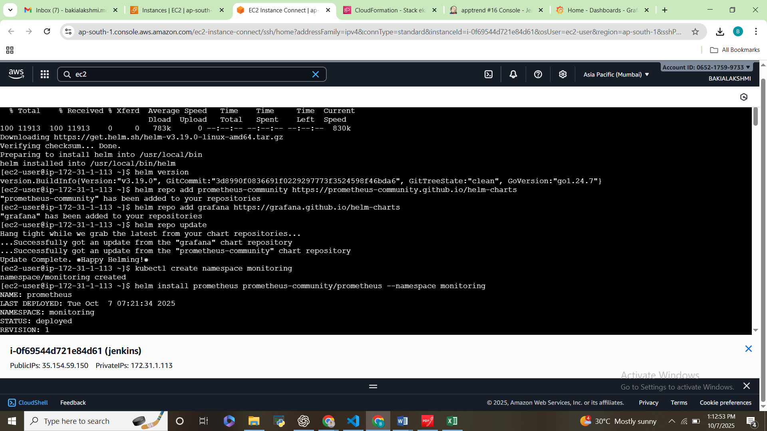

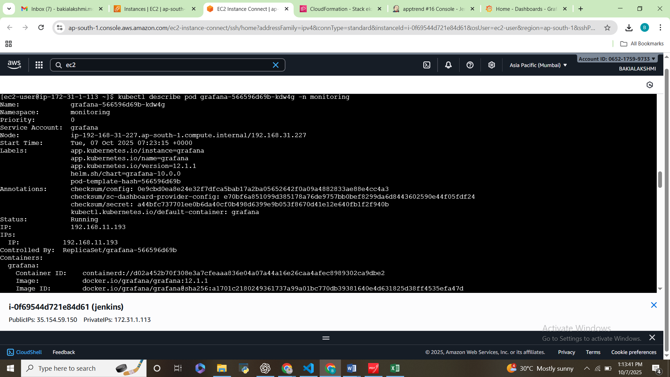

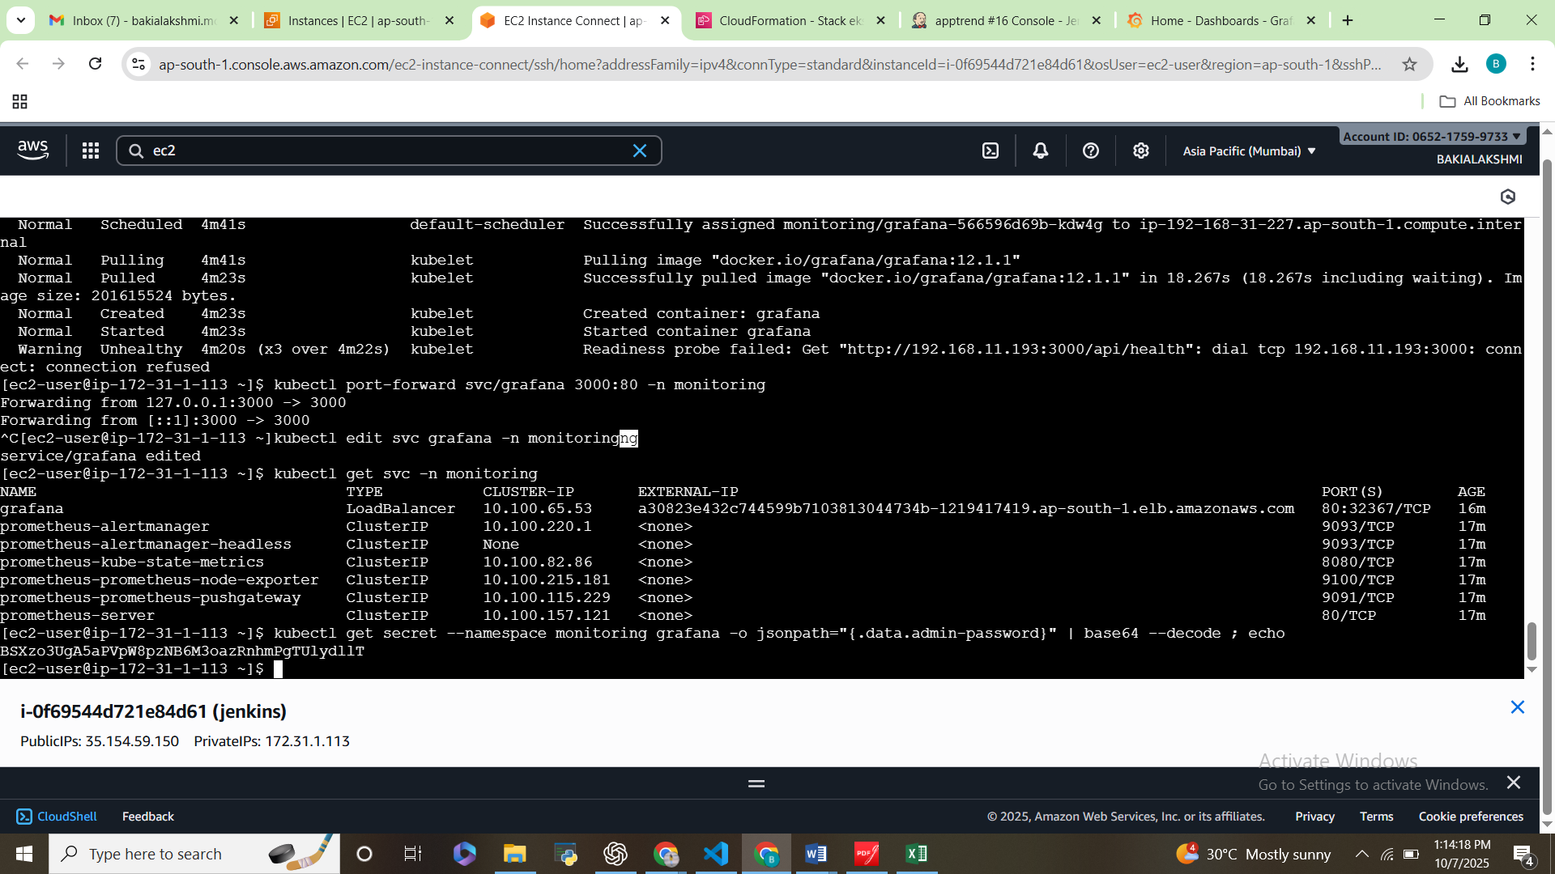

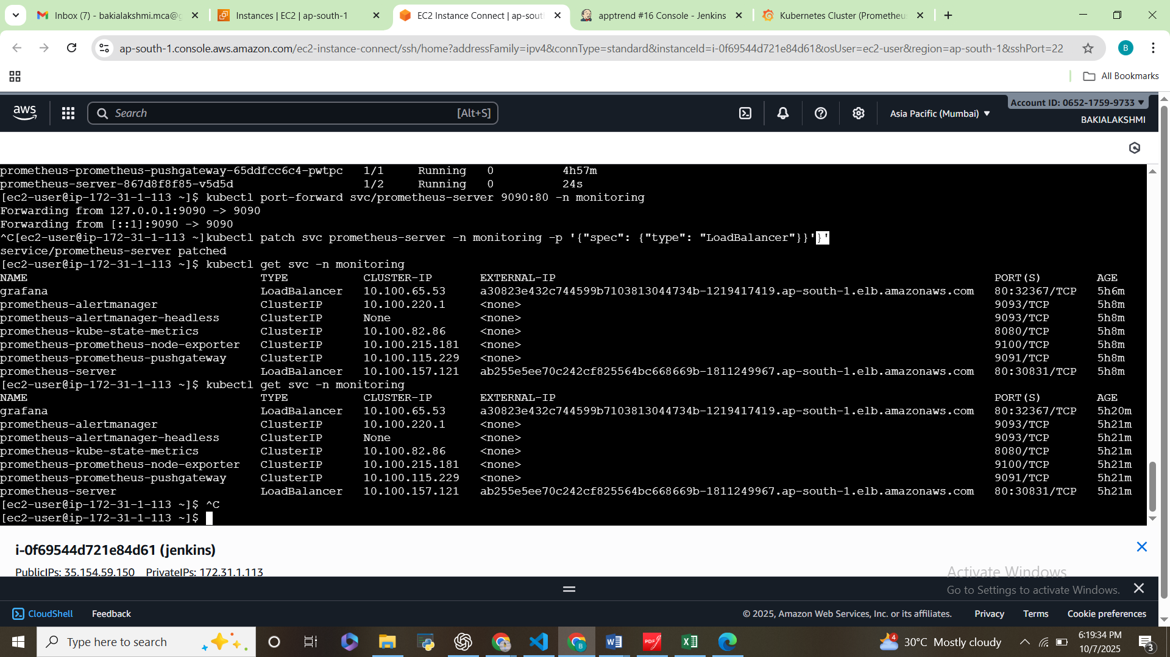

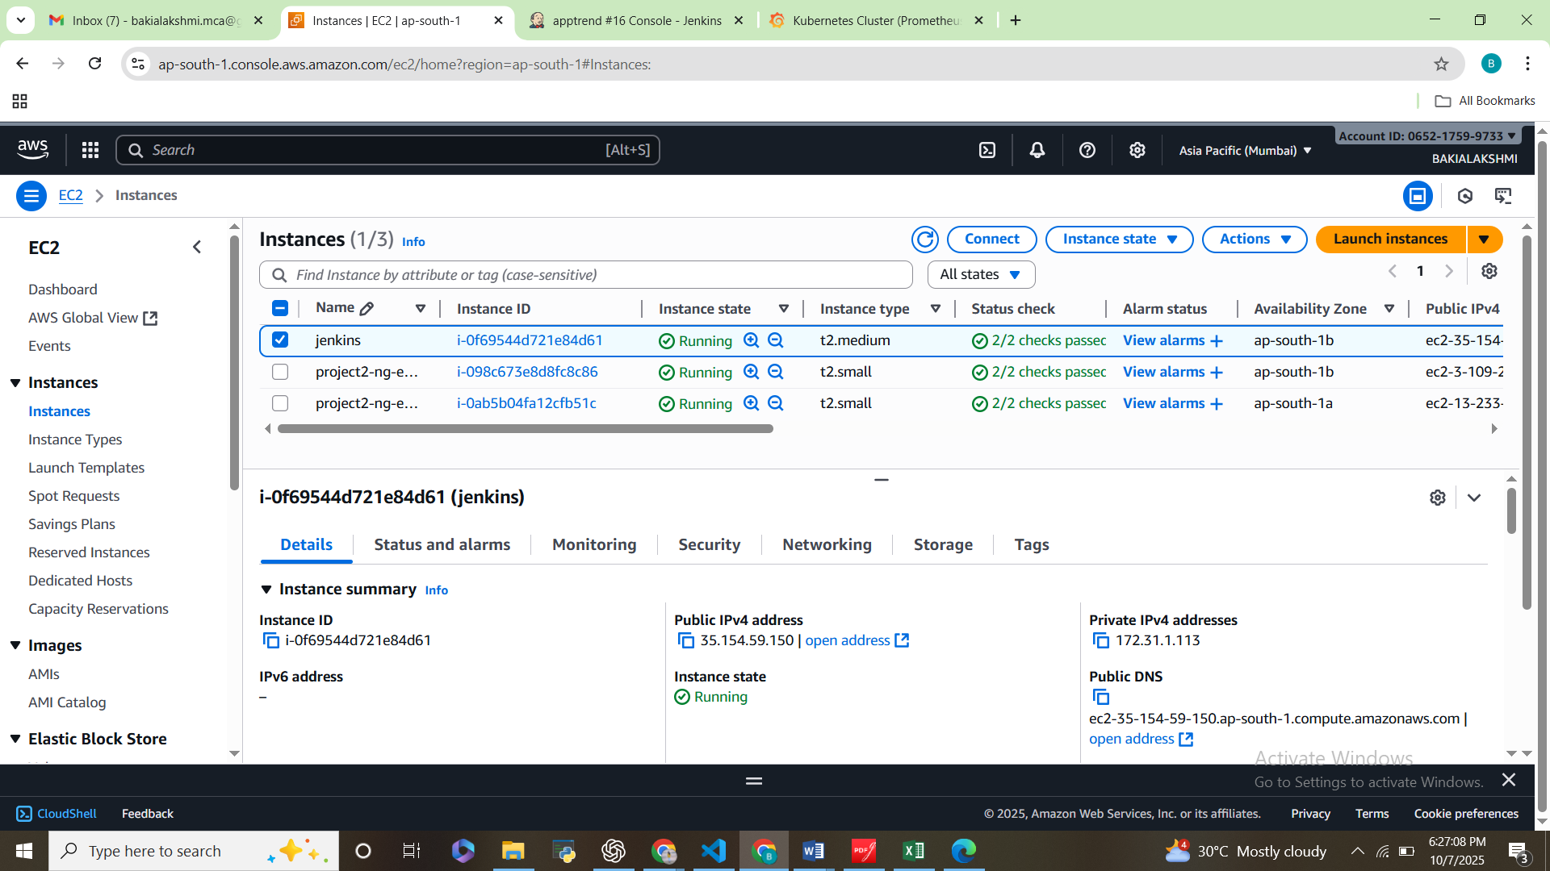

**5. Monitoring**

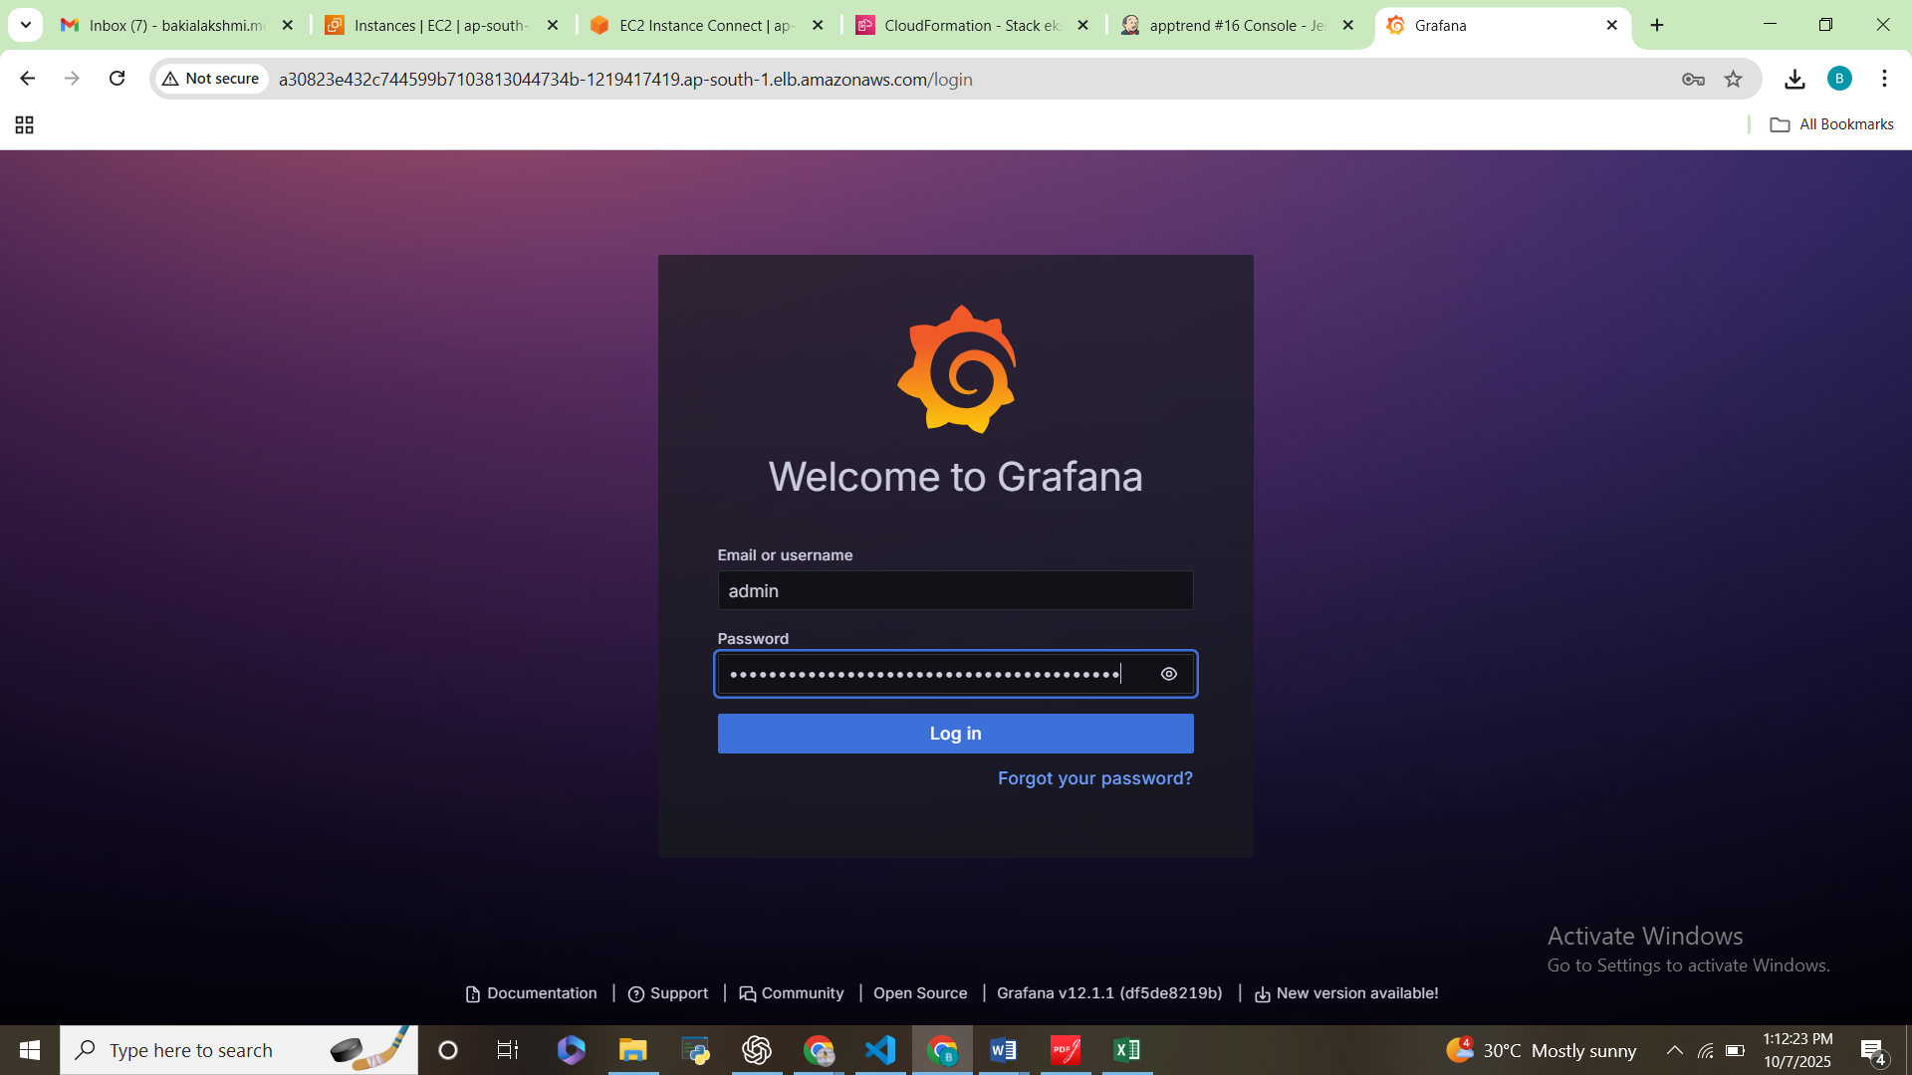

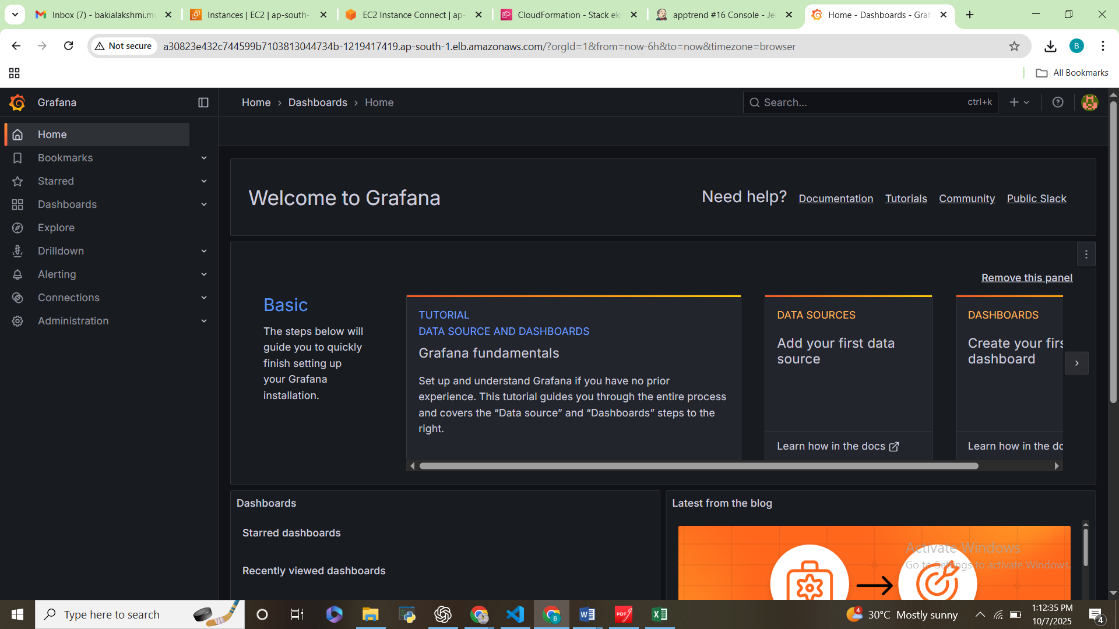

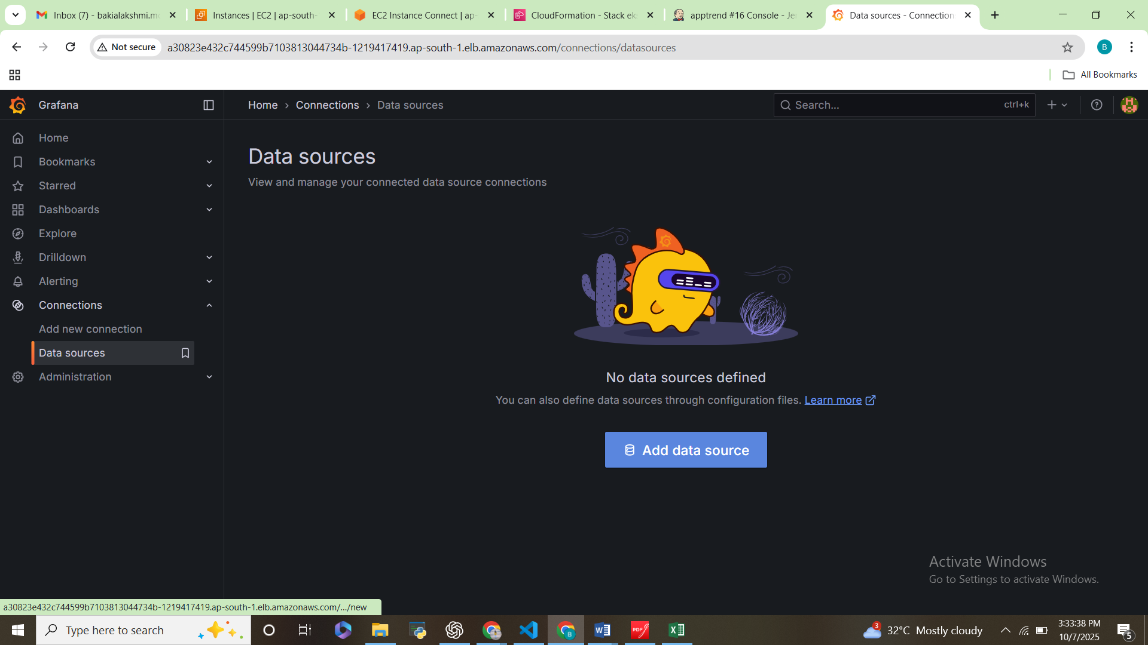

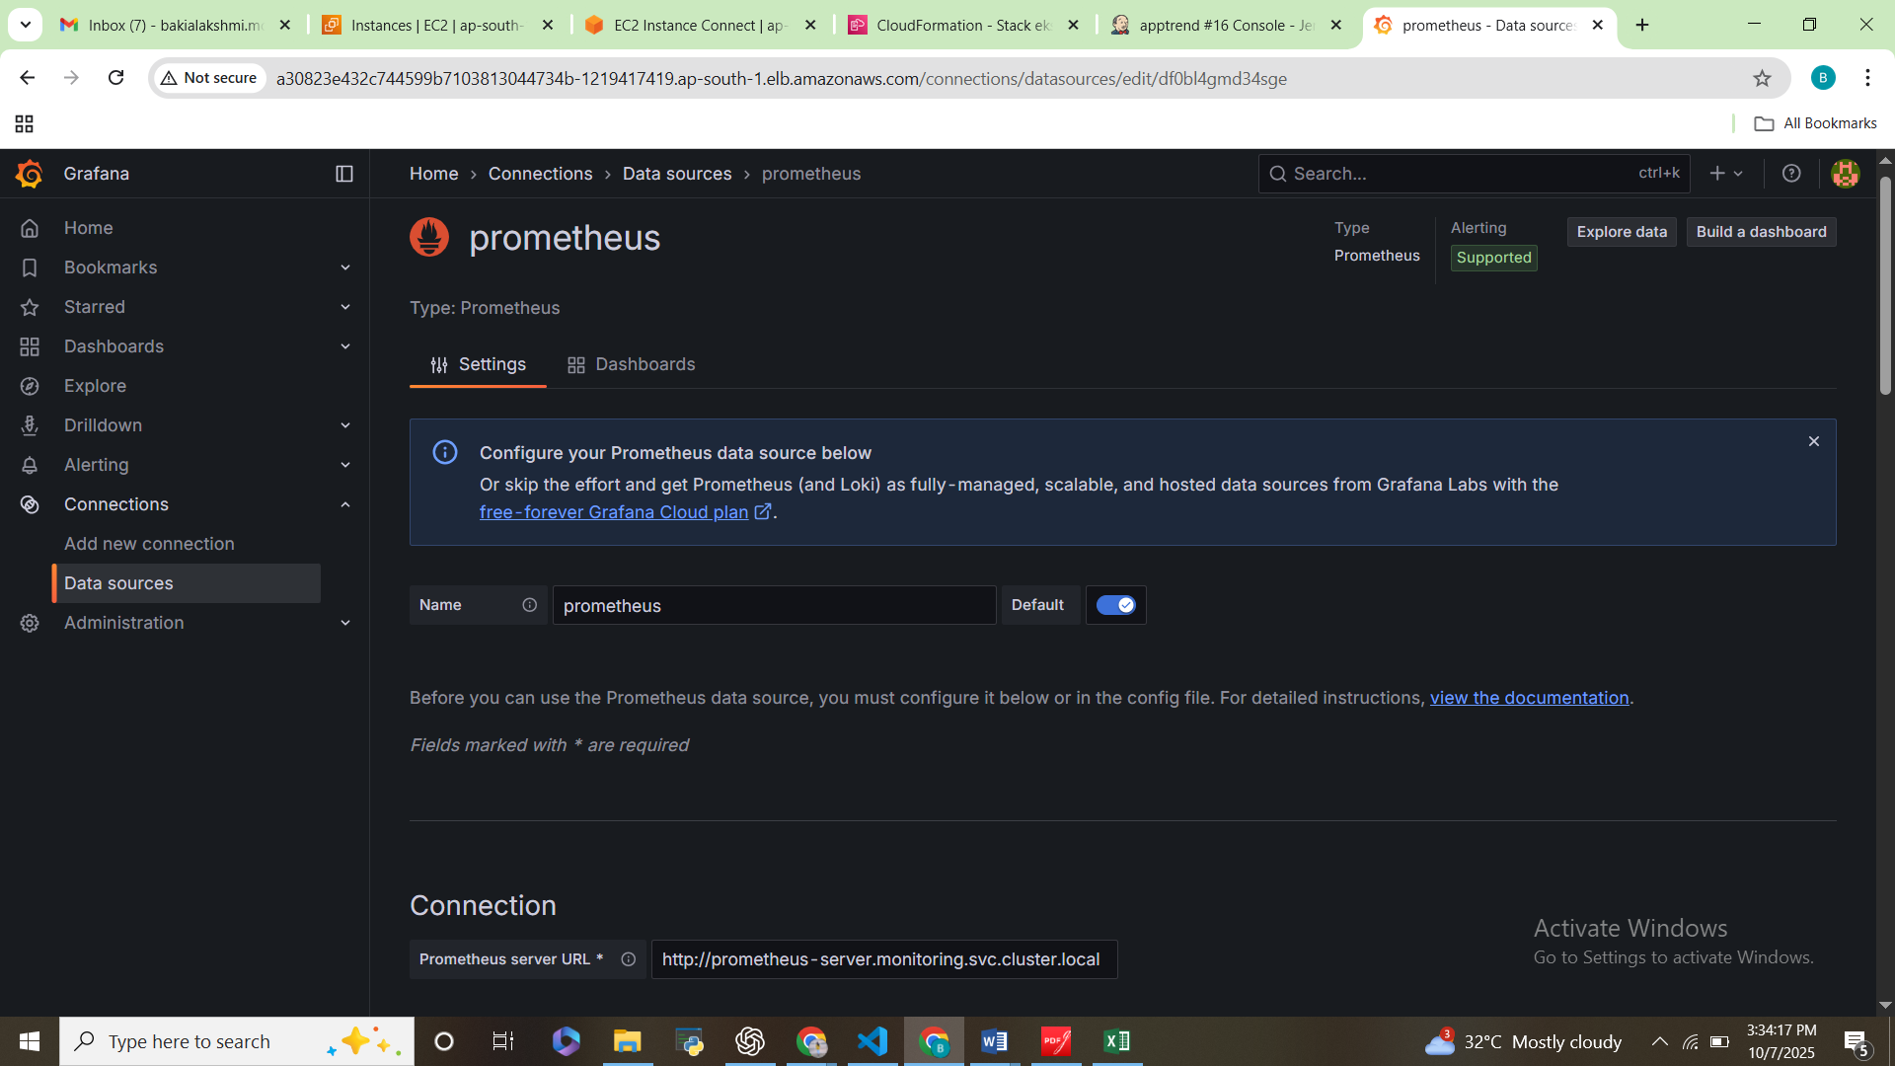

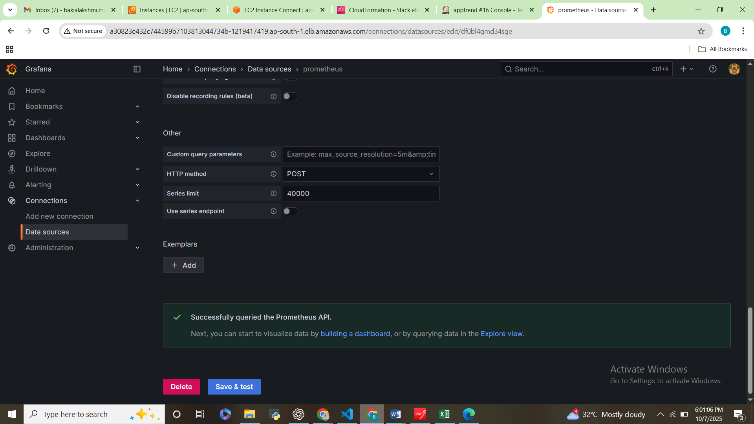

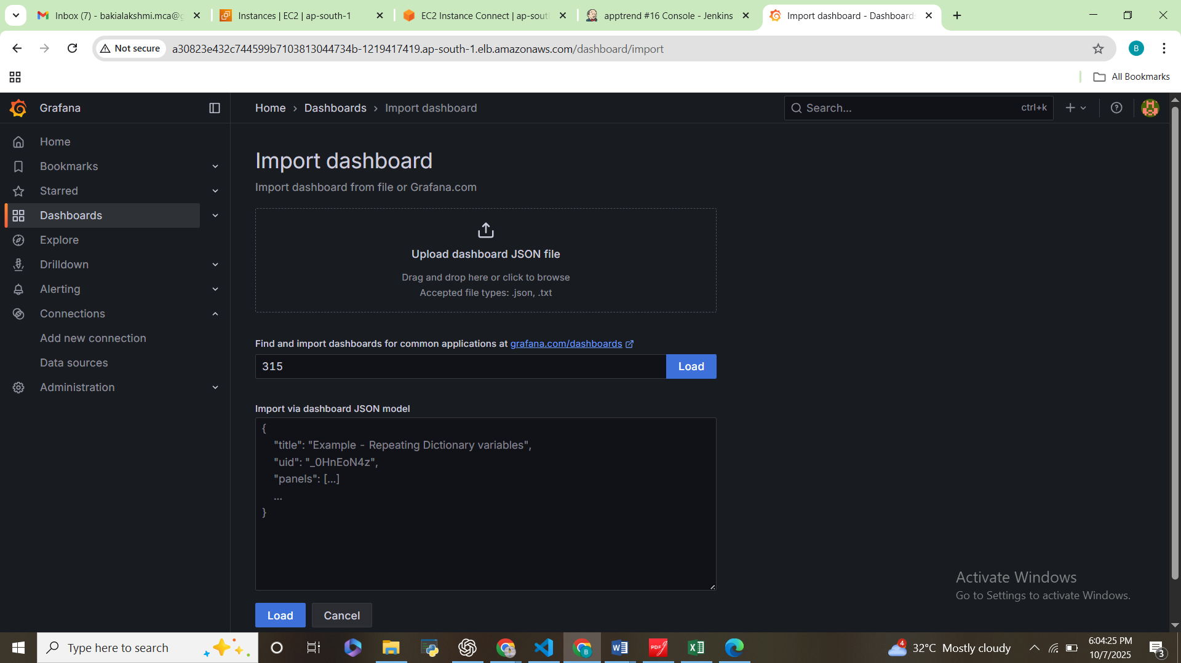

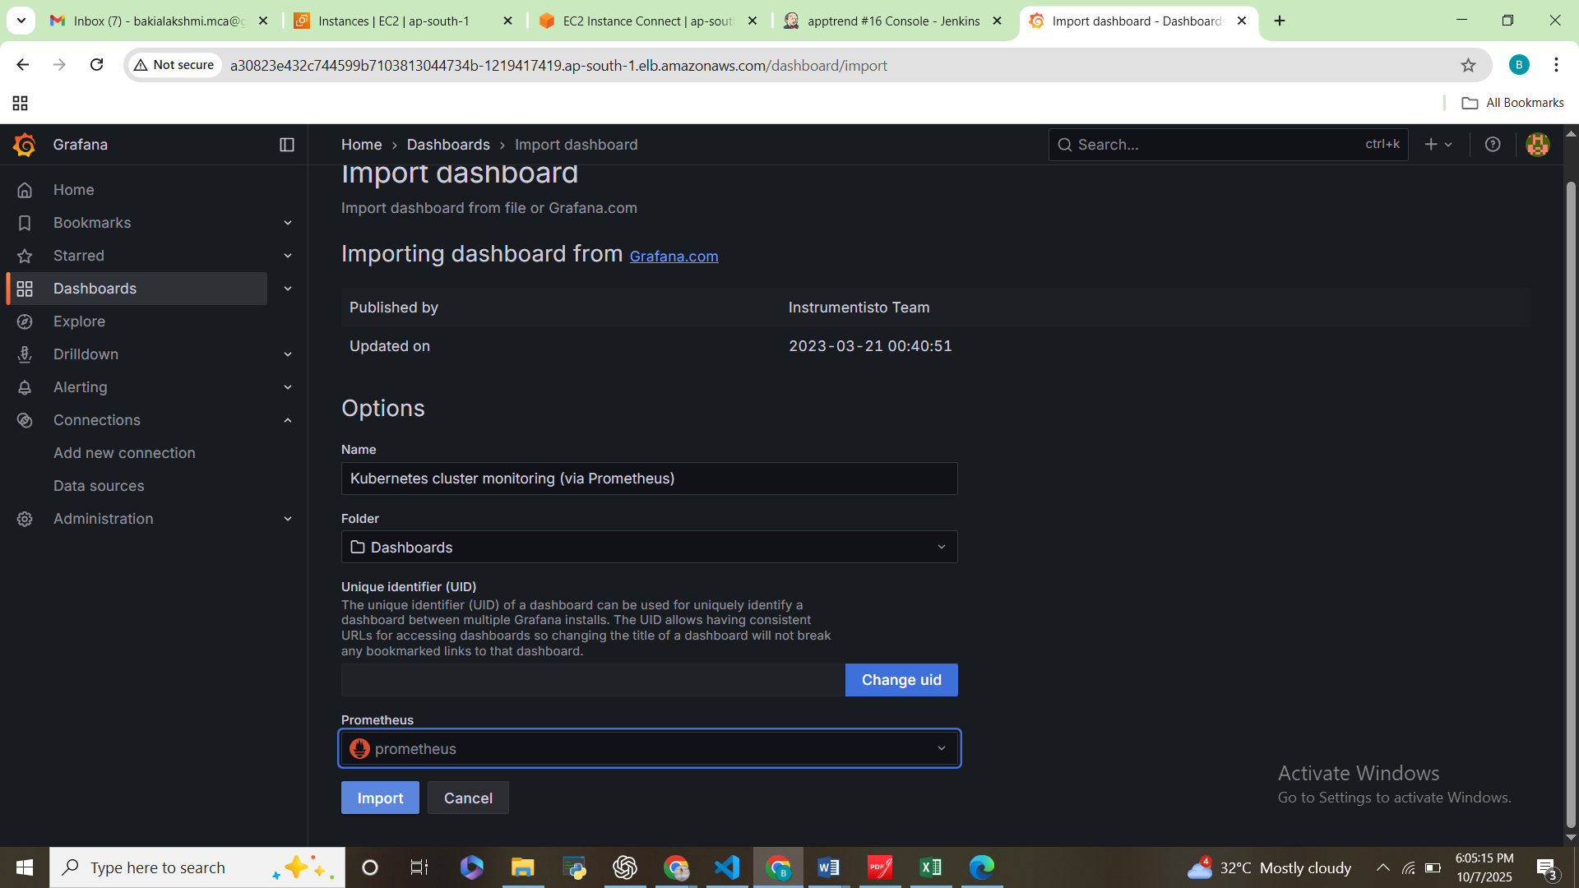

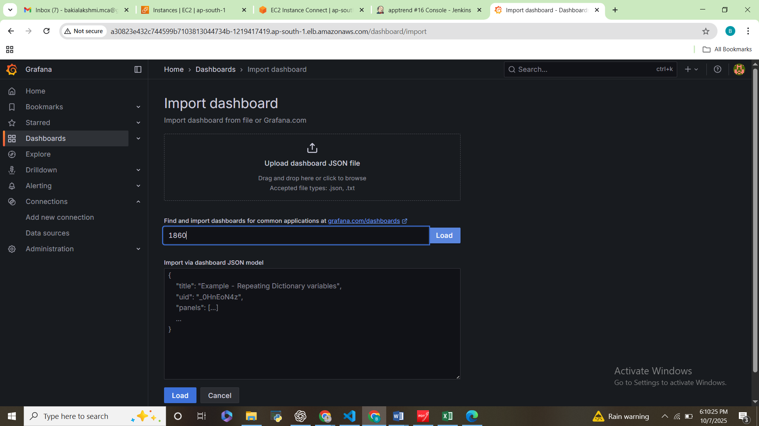

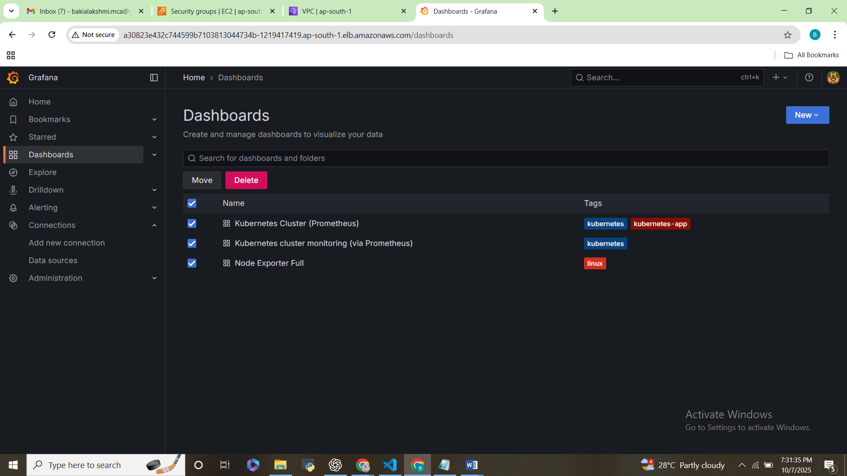

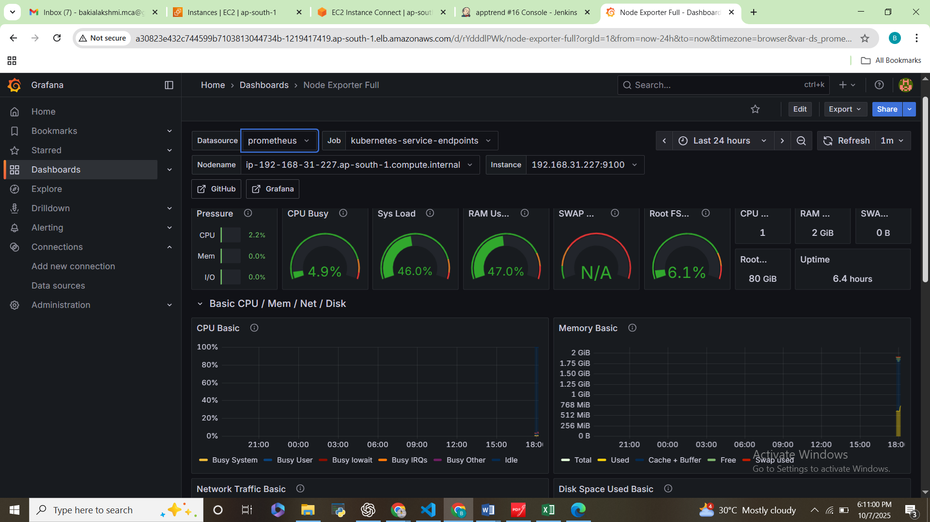

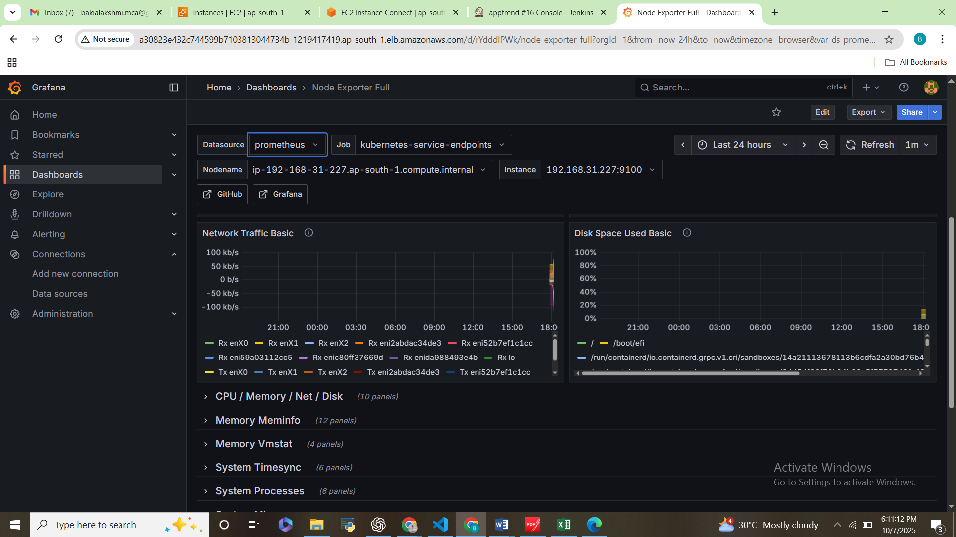

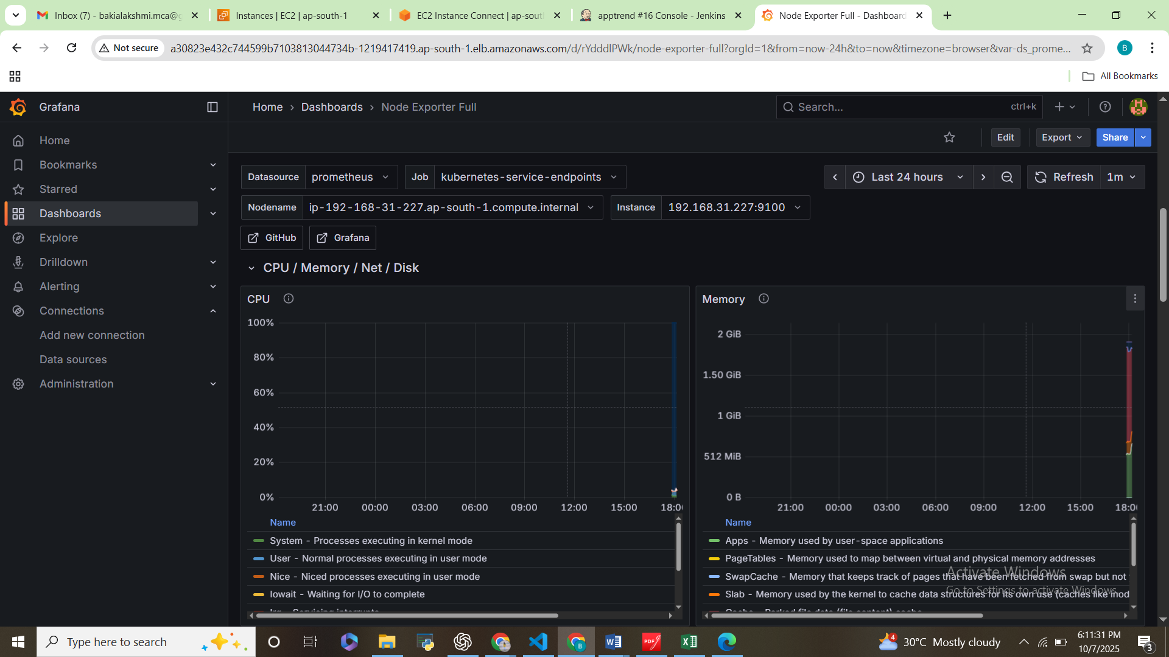

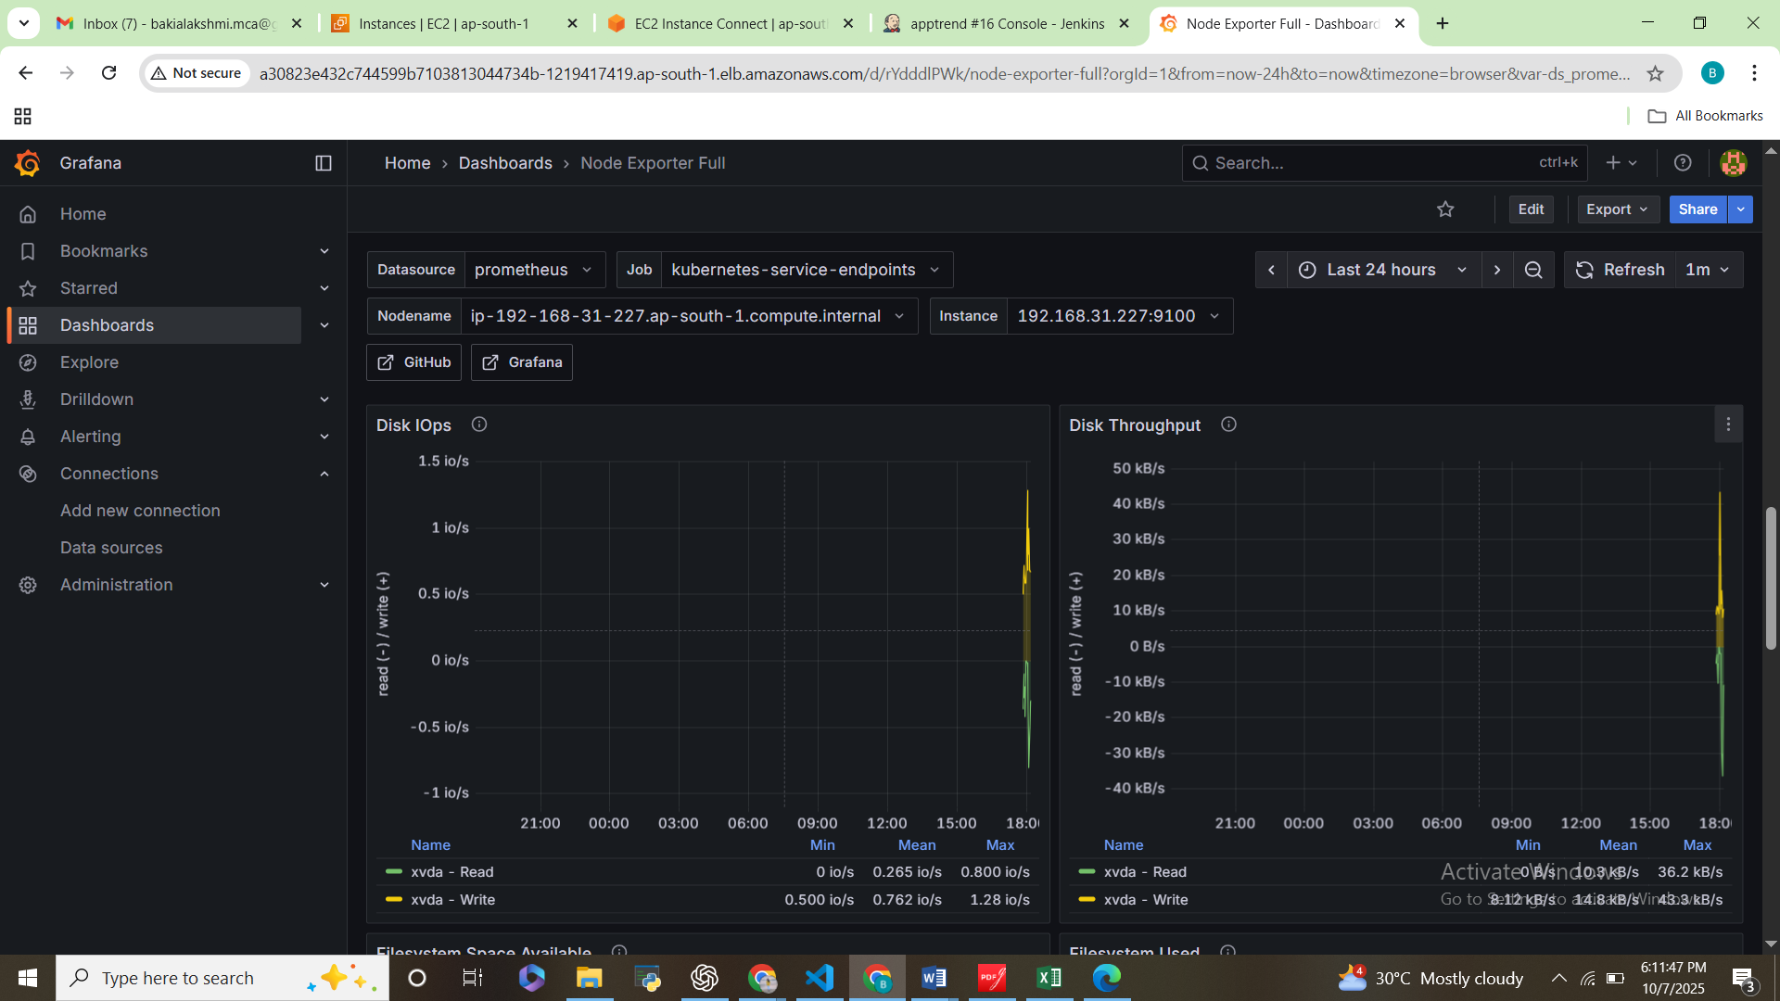

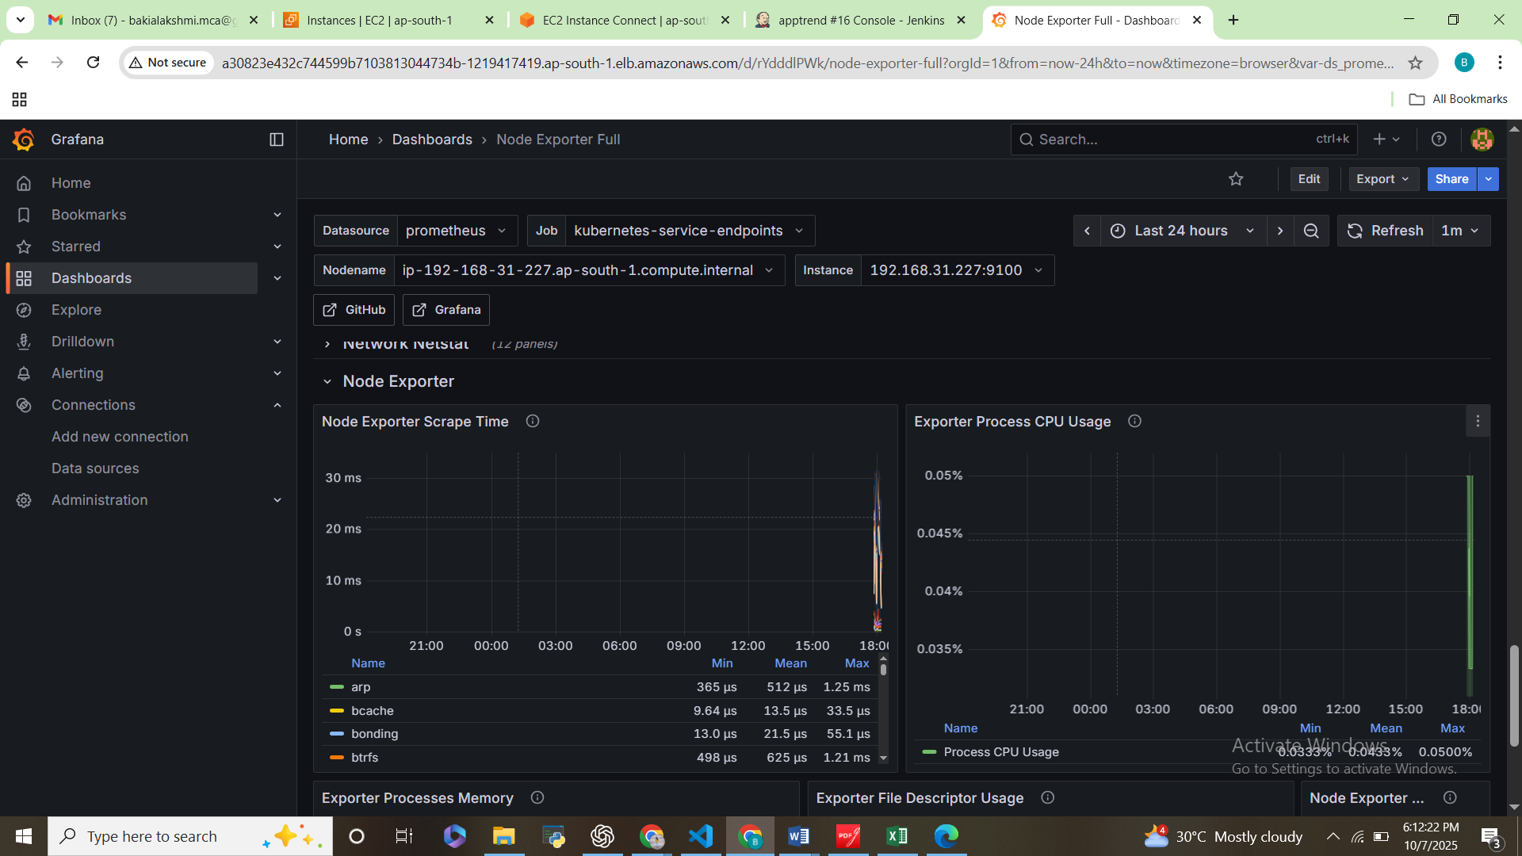

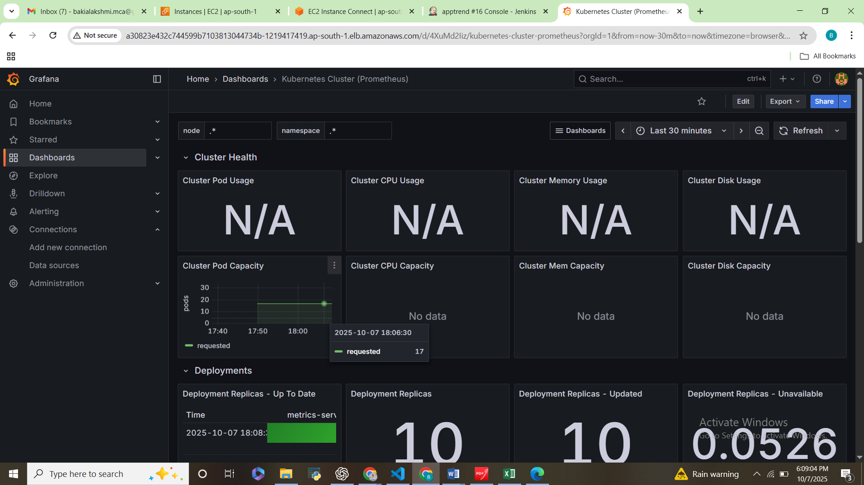

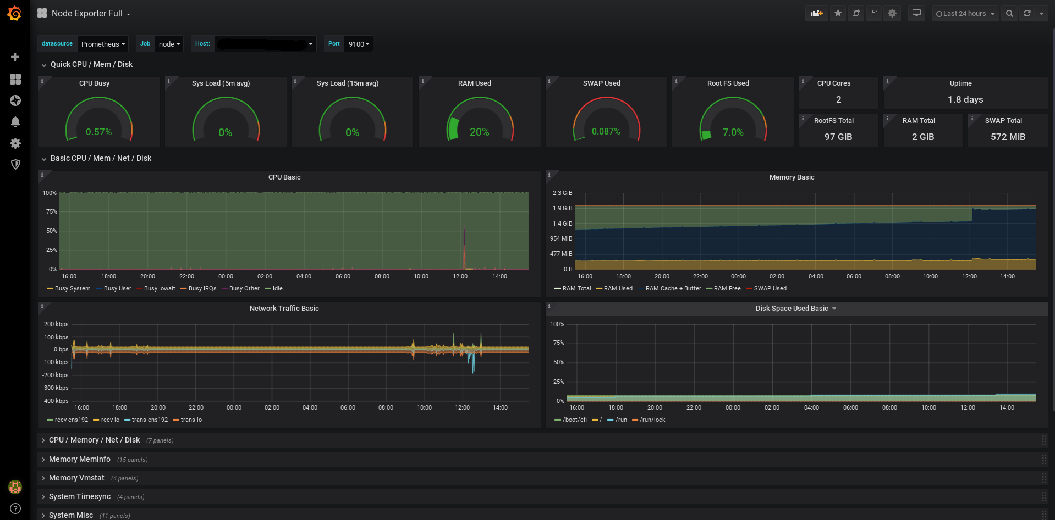

**Conclusion**

* Successfully automated TrendApp deployment using Jenkins & Kubernetes.
* Implemented monitoring with Prometheus & Grafana.
* Application and infrastructure health visible via dashboards.